|  |  |
| --- | --- |
| |  | | --- | | **MINISTRY OF EDUCATION AND TRAINING** | |
| Capstone Project Document |
| Taxi Caller Application on Windows Phone |
|  |
| |  |  |  |  | | --- | --- | --- | --- | | F-Taxi Team | | | | | **Group Members** | Phạm Gia Hữu | SE02705 | HuuPGSE02705 | |  | Nguyễn Văn Lập | SE02314 | LapNVSE02314 | |  | Tạ Thiên Hưởng | SE02900 | HuongTT SE02900 | |  | Phạm Ngọc Hoàn | SE02268 | HoanPN SE02268 | | **Supervisor** | Mr. Nguyễn Văn Sang | | | | **Capstone Project code** | **F-Taxi** | | | |
| **Hanoi, 16th December, 2015** |
|  |

# Table of contents

Table of contents 2

Table of figures 5

Definition and Acronyms 7

1 Introduction 8

1.1 Project information 8

1.2 Project members 8

1.2.1 Supervisors 8

1.2.2 Team members 8

1.3 Purposes 8

1.4 The existing system 8

1.4.1 Uber application 8

1.4.2 Grab Taxi application 9

1.5 Our proposal 9

1.6 Product 10

2 Software Project Management 11

2.1 Project Overview 11

2.1.1 Project Description 11

2.1.2 Scope Statement 11

2.2 Project Organization 14

2.2.1 Organizational Structure 14

2.2.2 Software Process Model 16

2.3 Project Schedule 17

2.3.1 Milestone and Deliverables 17

2.3.2 Task Sheet 18

2.3.3 Meeting Minutes 18

2.4 Risk Management 19

2.4.1 Risk register 19

2.5 Communication Management 20

2.5.1 Communication between Team Members 20

2.5.2 Communication with the Supervisor 21

2.6 Tools and Infrastructure 21

2.6.1 Software 21

2.6.2 Hardware 21

2.6.3 Others infrastructures 22

2.7 Coding conventions 22

3 Software Requirement Specification 23

3.1 SRS Overview 23

3.1.1 Purpose 23

3.1.2 Scope 23

3.2 Specific Requirements 23

3.2.1 External Interface Requirements 23

3.2.2 Functional Requirements 25

3.2.3 Non-Functional Requirements 65

4 Software Design Description 66

4.1 SDD Overview 66

4.2 Architecture Design 66

4.2.1 System Overall 66

4.2.2 Software Architect 67

4.3 Detail Design 69

4.3.1 Class Design 69

4.3.2 Sequence diagram 76

4.3.3 Screen Design 79

5 Software Test Documentation 104

5.1 Test Overview 104

5.1.1 Test Approach 104

5.1.2 Test Strategy 105

5.2 Test Plan 106

5.2.1 Feature to be tested 106

5.2.2 Feature not to be tested 107

5.2.3 Create test case plan 107

5.2.4 Execute test plan 108

5.2.5 Testing Environments 109

5.2.6 Resource 110

5.2.7 Test Milestones 110

5.3 Test Cases 111

5.3.1 Login 111

5.3.2 Register 113

5.3.3 Conflict 116

5.4 Test Report 117

5.4.1 Defect Log 117

5.4.2 Test Report 119

6 Software User Manual 120

6.1 INSTALLATION GUIDE 120

6.1.1 Purposes 120

6.1.2 Environments 120

6.2 USER's GUIDE 121

6.2.1 Guest 121

6.2.2 Rider 123

6.2.3 Driver 143

Reference 163

# Table of figures

Figure 2‑1 Project Organizational Structure 15

Figure 2‑2 Iterative and Incremental Software Process Model 17

Figure 3‑1 The Rider Use-case diagram 26

Figure 3‑2 Use-case UC-01 28

Figure 3‑3 Use-case UC-02 30

Figure 3‑4 Use-case UC-03 31

Figure 3‑5 Use-case UC-04 32

Figure 3‑6 Use-case UC-05 33

Figure 3‑7 Use-case UC-06 34

Figure 3‑8 Use-case UC-07 35

Figure 3‑9 Use-case UC-08 36

Figure 3‑10 Use-case UC-09 37

Figure 3‑11 Use-case UC-10 38

Figure 3‑12 Use-case UC-11 39

Figure 3‑13 Use-case UC-12 40

Figure 3‑14 Use-case UC-13 41

Figure 3‑15 Use-case UC-14 42

Figure 3‑16 Use-case UC-15 43

Figure 3‑17 Use-case UC-16 44

Figure 3‑18 Use-case UC-17 45

Figure 3‑19 Use-case UC-18 46

Figure 3‑20 Use-case UC-19 47

Figure 3‑21 The Driver Use-case diagram 48

Figure 3‑22 Use-case UC-20 49

Figure 3‑23 Use-case UC-21 50

Figure 3‑24 Use-case UC-22 51

Figure 3‑25 Use-case UC-23 52

Figure 3‑26 Use-case UC-24 53

Figure 3‑27 Use-case UC-25 54

Figure 3‑28 Use-case UC-26 55

Figure 3‑29 Use-case UC-27 56

Figure 3‑30 Use-case UC-28 57

Figure 3‑31 Use-case UC-29 58

Figure 3‑32 Use-case UC-30 59

Figure 3‑33 Use-case UC-31 60

Figure 3‑34 Use-case UC-32 61

Figure 3‑35 Use-case UC-33 62

Figure 3‑36 Use-case UC-34 63

Figure 4‑1 System Overall 65

Figure 4‑2 Layered architecture for F-Taxi application 66

Figure 6‑1 V-model 98

Table 1‑1 F-Taxi team members 10

Table 2‑1 Project description 13

Table 2‑2 Main Application function list 13

Table 2‑4 Roles and Responsibilities 16

Table 2‑5 Milestone and Deliverables 18

Table 2‑6 Meeting Minutes 1 19

Table 2‑7 Risk register 20

Table 2‑8 Software needed for project 21

Table 3‑1 Rider Use-cases 26

Table 3‑2 Use-case UC-01 specification 28

Table 3‑3 Use-case UC-02 specification 30

Table 3‑4 Use-case UC-03 specification 31

Table 3‑5 Use-case UC-04 specification 32

Table 3‑6 Use-case UC-05 specification 33

Table 3‑7 Use-case UC-06 specification 34

Table 3‑8 Use-case UC-07 specification 35

Table 3‑9 Use-case UC-08 specification 36

Table 3‑10 Use-case UC-09 specification 37

Table 3‑11 Use-case UC-10 specification 38

Table 3‑12 Use-case UC-11 specification 39

Table 3‑13 Use-case UC-12 specification 40

Table 3‑14 Use-case UC-13 specification 41

Table 3‑15 Use-case UC-14 specification 42

Table 3‑16 Use-case UC-15 specification 43

Table 3‑17 Use-case UC-16 specification 44

Table 3‑18 Use-case UC-17 specification 45

Table 3‑19 Use-case UC-18 specification 46

Table 3‑20 Use-case UC-19 specification 47

Table 3‑21 Driver Use-cases 48

Table 3‑22 Use-case UC-20 specification 49

Table 3‑23 Use-case UC-21 specification 50

Table 3‑24 Use-case UC-22 specification 51

Table 3‑25 Use-case UC-23 specification 52

Table 3‑26 Use-case UC-24 specification 53

Table 3‑27 Use-case UC-25 specification 54

Table 3‑28 Use-case UC-26 specification 55

Table 3‑29 Use-case UC-27 specification 56

Table 3‑30 Use-case UC-28 specification 57

Table 3‑31 Use-case UC-29 specification 58

Table 3‑32 Use-case UC-30 specification 59

Table 3‑33 Use-case UC-31 specification 60

Table 3‑34 Use-case UC-32 specification 61

Table 3‑35 Use-case UC-33 specification 62

Table 3‑36 Use-case UC-34 specification 63

Table 5‑1 Feature to be tested 100

Table 5‑2 Create test cases plan 101

Table 5‑3 Execute test plan 101

Table 5‑4 Software needed for testing 102

Table 5‑5 Resource and Responsibility in Test process 102

Table 5‑6 Test milestones 103

Table 5‑7 Login test cases 104

Table 5‑8 Register test cases 105

Table 5‑9 Conflict 108

Table 5‑10 Test report 109

# Definition and Acronyms

|  |  |  |
| --- | --- | --- |
| Acronym | Definition | Note |
| F-Taxi | Taxi Caller Application on Window Phone |  |
| PM | Project Manager |  |
| PTL | Project Technical Leader |  |
| QA | Quality Assurance |  |
| PMP | Project Management Plan |  |
| SRS | Software Requirement Specification |  |
| SATD | Software Architecture Design | Design document, included in SDD |
| SDTD | Software Detail Design |
| SDD | Software Design Description |  |
| STD | Software Test Documentation |  |
| UT | Unit Test |  |
| IT | Integration Test |  |
| ST | System Test |  |
| R1 | Round 1 | System Test |
| R2 | Round 2 |
| AT | Acceptance Test |  |
| UC | Use-case |  |
| SC | Screen |  |
| UI | User Interface |  |
| GUI | Graphical User Interface |  |
| PRL | Presentation Layer | Layers of software system |
| BOL | Business Operation Layer |
| DAL | Data Access Layer |
| ERD | Entity-Relationship diagram |  |
| DB | Database |  |
| SUG | Software User Manual |  |
| T-Net | T-Net Solution |  |

# Introduction

## Project information

* **Project Name:** Taxi Caller Application on Windows Phone
* **Project Code:** F-Taxi
* **Project Type:** Windows Phone Application
* **Timeline:** from 7th September 2015 to 14th December 2015

## Project members

### Supervisors

|  |  |  |  |
| --- | --- | --- | --- |
| Full name | Phone | E-Mail | Title |
| Nguyễn Văn Sang |  | SangNV@fpt.edu.vn | Lecturer |

### Team members

**Table 1‑1** F-Taxi team members

|  |  |  |  |  |
| --- | --- | --- | --- | --- |
| Full name | Roll no. | Phone | E-mail | Position |
| Phạm Gia Hữu | SE02705 |  | [HuuPGSE02705@fpt.edu.vn](mailto:HuuPGSE02705@fpt.edu.vn) | Leader |
| Nguyễn Văn Lâp | SE02314 |  | [LapNVSE02314@fpt.edu.vn](mailto:LapNVSE02314@fpt.edu.vn) | Member |
| Tạ Thiên Hưởng | SE02900 |  | [HuongTTSE02900@fpt.edu.vn](mailto:HuongTTSE02900@fpt.edu.vn) | Member |
| Phạm Ngọc Hoàn | SE02268 |  | [HoanPNSE02268@fpt.edu.vn](mailto:HoanPNSE02268@fpt.edu.vn) | Member |

## Purposes

A window phone application to help user using window phone OS want call a taxi with a taxi driver from taxi company communication easy. Call a taxi, pick up customer … with a few actions from screen.

## The existing system

### Uber application

Pros:

* Provide information about taxi which is near user.
* There are a lot of taxi brands, so user can have many choices

Cons:

* Not support Vietnamese on Windows phone.

### Grab Taxi application

Pros:

* Provide information about taxi which is near user.

Cons:

* Not support on Windows phone

## Our proposal

A window phone application to help user using window phone OS want call a taxi with a taxi driver from taxi company communication easy. Call a taxi, pick up customer … with a few actions from screen.

## Product

* This software is a windows phone application help user take a trip and pick up a customer easy. Show information of trip, taxi instance for user.
* System will working with internet connection, 2 user is Rider and Driver had login application. The most importance is have internet connection. The main function of this application is help customer as Rider easy take a taxi with information from taxi driver and price, in other hand taxi driver as Driver have more customer from user using Windows Phone, and know information about trip and customer.
* Purpose of this application is help Rider and Driver communicate better because have many trusted from application

# Software Project Management

## Project Overview

### Project Description

**Table 2‑1** Project description

|  |  |  |  |  |
| --- | --- | --- | --- | --- |
| **Project name:** | **Taxi Caller Application on Windows Phone** | | | |
| **Project Code:** | F-Taxi | | | |
| **Project manager:** | Phạm Gia Hữu | | | |
| **Project category:** | **🗹 New development** | | **🞎 Maintenance** | **🞎 Other** |
| **Business domain:** | Windows application | | | |
| **Scope and Objective** | * Objective: • The main objective of the project is creating application for window phone user, help user using app for take a taxi quickly and taxi driver pick up a customer easy. * Products:   + This software is a windows phone application help user take a trip and pick up a customer easy. Show information of trip, taxi instance for user.   + System will working with internet connection, 2 user is Rider and Driver had login application. The most importance is have internet connection. The main function of this application is help customer as Rider easy take a taxi with information from taxi driver and price, in other hand taxi driver as Driver have more customer from user using Windows Phone, and know information about trip and customer.   + Purpose of this application is help Rider and Driver communicate better because have many trusted from application * Scope: On Windows phone | | | |
| **Project start date:** 2015/09/07 | | **Expected end date:** 2015/12/14 | | |
| **Planned duration:** | **75 days** | | | |

### Scope Statement

The scope of this project includes these stages:

* Develop user requirement and software requirement specification.
* Develop architecture and detailed design documents.
* Coding and unit test.
* Develop test case and execute combination test.

The released software product is Taxi Caller application that will have function list as below:

**Table 2‑2** Main Application function list

|  |  |  |  |  |  |
| --- | --- | --- | --- | --- | --- |
| No. | Component | | Feature Name | | Feature to be tested |
|  | Interface | Rider screen | Screen elements | | Check the display of elements. |
| Driver screen |
|  | Function | Main application |  | Login | Login |
|  |  | Logout | Logout |
|  | Account management |  | Register account |
|  | View profile |
|  | Update profile |
|  | Change password |
|  | Forget password |
|  | Rider actions | Work with trips | Create trip |
|  | Cancel trip |
|  | View completed trips |
|  | View bill detail |
|  | Rate driver |
|  | Favorites management | View favorite driver |
|  | Add favorite driver |
|  | Delete favorite driver |
|  | Call favorite driver |
|  | Find lost assets | Find lost assets |
|  | Send Application Feedback | Send Application Feedback |
|  | Call Taxi Center | Call Taxi Center |
|  | Driver actions | Work with trips | Accept trip |
|  | Reject trip |
|  | Cancel trip |
|  | Complete trip |
|  | Start trip |
|  | View bill detail |
|  | V.I.P customer management | View V.I.P customer |
|  | Add V.I.P customer |
|  | Delete V.I.P customer |
|  | Notify lost assets | Notify lost assets |
|  | Change status | Change status |
|  | Conflict |  | Conflict | | |

## Project Organization

### Organizational Structure

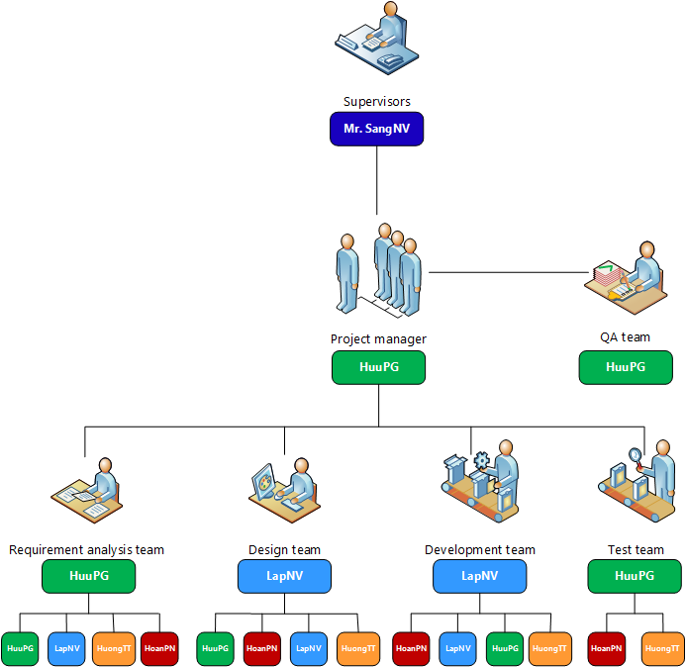

Figure 2‑1 Project Organizational Structure

**Table 2‑4** Roles and Responsibilities

|  |  |  |
| --- | --- | --- |
| Full name | Roles in project | Responsibilities |
| Phạm Gia Hữu | Project manager | Develop project plan  Manage project stakeholders, project team and resolve conflicts  Manage project schedule, project risk  Communication with members and supervisor, include weekly plan, weekly status report, hold meetings and assure to submit reports to supervisor on schedule.  Manage data synchronization in project |
| Requirement analysis | Create and co-operate with members to develop: SRS and SDD  Create document format standards and coding conventions. |
| Architect designer |
| Detail designer |
| Developer | Provide tools for project development process  Co-operate with members to coding and fix bug (auxiliary) |
| Tester | Execute test to ensure all functions fulfil requirements  Review all documents and reports. Translation, and check language grammar and spelling (on English) |
| Quality assurance | Ensure that the project is completed on schedule and within scope  Review all documents, reports and assure product quality |
| Nguyễn Văn Lập | Requirement analysis | Co-operate with members to develop SRS and SDD  Co-operate with members to develop GUI for application |
| Architect designer |
| GUI designer |
| Architect designer |
| Detail designer |
| Developer | Co-operate with members to coding (auxiliary) |
| Tạ Thiên Hưởng | Requirement analysis leader | Conduct overall business process |
| Co-operate with members to develop SRS |
| Tester | Execute test to ensure all functions fulfil requirements |
| Developer | Provide suitable technology solutions  Co-operate with members to coding and fix bug (main) |
| Phạm Ngọc Hoàn | QA | Ensure that the project is completed on schedule and within scope |
| Tester | Create test cases for the system, both in document and script  Execute test to ensure all functions fulfil requirements |
| Developer | Provide suitable technology solutions  Co-operate with members to coding and fix bug (main) |

### Software Process Model

To develop the system, we decided to use the Iterative and Incremental Software Process Model.

.

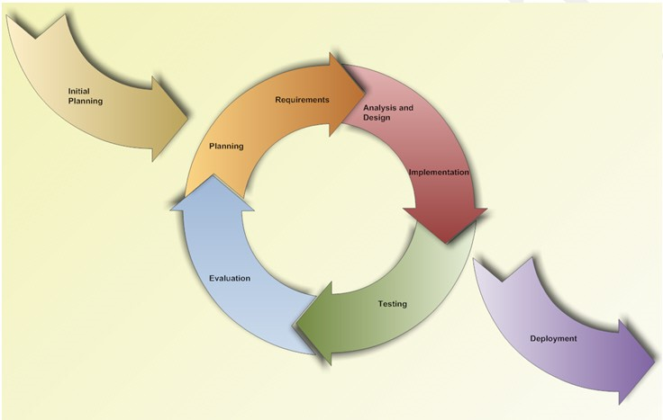

Figure 2‑2 Iterative and Incremental Software Process Model

Why this model was chosen:

* We can learn from time to time during our process, and use anything we learned to improve the product.
* Through every iteration, we are able to control scope and requirements, flexibly update or even change anything if we think it will help us to have a better product.
* Customers can respond after each build of the product.
* It is easy to manage risks by dividing into many pieces and solve it as quick as possible in each iteration.
* It is also easy to test and debug during a smaller iteration.

## Project Schedule

### Milestone and Deliverables

**Table 2‑5** Milestone and Deliverables

|  |  |  |  |  |
| --- | --- | --- | --- | --- |
| No. | Phase | Deliverable/ Milestone | Delivery Date | Delivery Location |
|  | Definition | Project identification | 2015/09/07 | Project team |
|  |  | Deliver Report 1 | 2015/09/15 | Supervisor |
|  |  | Deliver Report 2 | 2015/09/21 | Supervisor |
|  | Solution | Complete Function analysis | 2015/09/25 | Project team |
|  |  | Deliver Report 3 | 2015/10/03 | Supervisor |
|  |  | Complete Architectural Design | 2015/10/04 | Project team |
|  | Construction | Complete Detail Design | 2015/10/10 | Project team |
|  |  | Deliver Report 4 | 2015/10/17 | Supervisor |
|  |  | Complete coding | 2015/10/29 | Project team |
|  |  | Complete system testing | 2015/11/14 | Project team |
|  |  | Deliver Report 5 | 2015/11/14 | Supervisor |
|  |  | Deliver Report 6 | 2015/12/04 | Supervisor |
|  |  | Complete full source code | 2015/12/07 | Project team |
|  | Transition | Complete fully project product | 2015/12/10 | Project team |
|  |  | Deliver Final Report & CD | 2015/12/16 | Supervisor, FU |
|  |  | Complete Presentation slide | 2015/12/16 | Supervisor, FU |
|  |  | Project completed | 2015/12/24 | Project team |

### Task Sheet

**Gantt chart:** refer to F-Taxi schedule task sheet. Example :

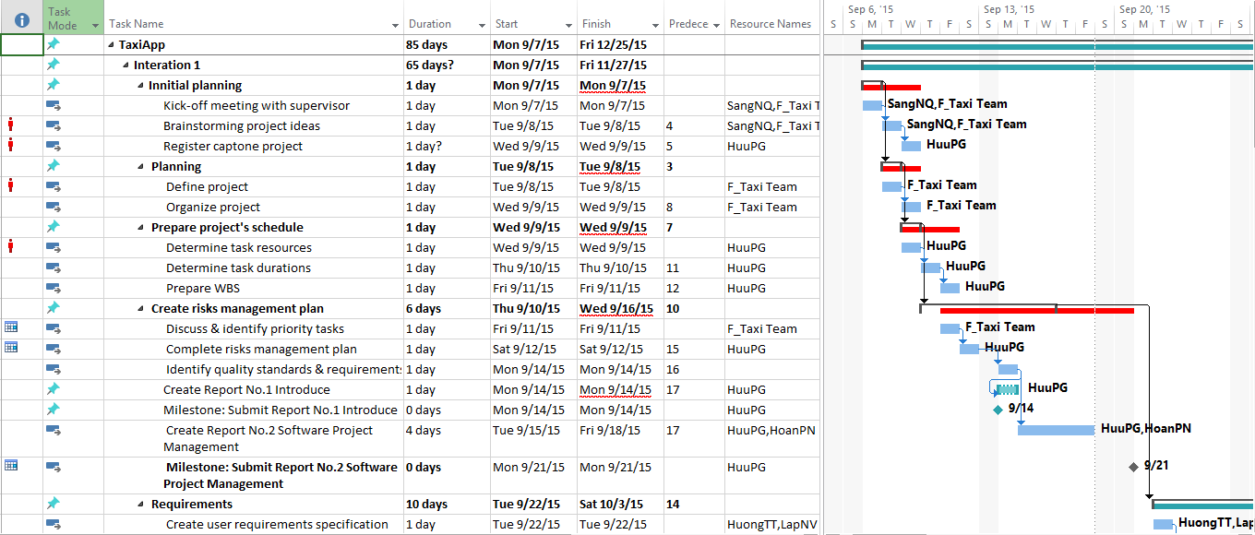

### Meeting Minutes

Below is one of our meeting minute records. All other meeting minutes refer to Meeting minutes folder.

**Table 2‑6** Meeting Minutes 1

|  |  |  |  |  |  |  |  |
| --- | --- | --- | --- | --- | --- | --- | --- |
| **Project:** | | Taxi caller | | **Project Code:** | | F-Taxi | |
| **Project Manager:** | | Phạm Gia Hữu | | **Conductor:** | | Nguyễn Văn Sang | |
| **Secretary:** | | Phạm Gia Hữu | |
| **Date:** | | 2015/09/20 | | **Time:** | | 13:00 AM – 15:00 | |
| **Venue:** | | FPT University Hòa Lạc | | | | | |
| **Meeting topic:** | | Check report 1 and remind plan | | | | | |
| **Attendees:** | | | | | | | |
| **No** | **Full name** | | **Unit/Group** | | **Position** | | **Attendance** |
| 1 | Nguyễn Văn Sang | | FPT University | | Supervisor | | Present |
| 2 | Phạm Gia Hữu | | F-Taxi team | | Project manager | | Present |
| 3 | Nguyễn Văn Lập | | F-Taxi team | | Member | | Present |
| 4 | Phạm Ngọc Hoàn | | F-Taxi team | | Member | | Present |
| 5 | Tạ Thiên Hưởng | | F-Taxi team | | Member | | Present |
| **Objectives:** | | | | | | | |
| Meeting review report 1 and remind plan | | | | | | | |
| **Agenda:** | | | | | | | |
| * Team member problems * Project introduction | | | | | | | |
| **Contents:** | | | | | | | |
| 1, Team member problems   * All the activities, the issues will be discussed and reported with supervisor in last week. * Discuss all issues & problems on the job last week * Discuss the working plan next week   2, Project introduction   * Instruct the direction for project team to deal with the problems * Support & comments the working ​​plans next week | | | | | | | |
| **Conclusion:** | | | | | | | |
| **Discussed Items** | | | **Decisions** | | | | |
| 1, Team member problems | | | Project manager need to hold a meeting with all members’ present, discuss and re-report in the next meeting | | | | |

## Risk Management

### Risk register

**Table 2‑7** Risk register

|  |  |  |  |  |
| --- | --- | --- | --- | --- |
| ID | Risk Content | Probability | Effect | Solution |
| # | **People Risks** |  |  |  |
| 1 | Team member may not follow deadlines. | HIGH | SERIOUS | * Find out reasons * Depending on circumstances, may set penalty rule. |
| 2 | Team members are sick, cannot complete task under deadline. | HIGH | SERIOUS | * Increase project team’s working effort in “peace period”. * Allow all team members clear about what others do, so that they can cover the tasks when necessary. |
| 3 | Conflict between team members. | HIGH | SERIOUS | * Setup an open-talk environment in project team. * “*Do not criticize*” is set as a rule. * Organize team-building more often. * In some cases, manager must use his power to make decisions. |
| 4 | New technology is hard to apply for project | HIGH | SERIOUS | * List tasks and check continuously. Evaluate quality and progress weekly. * Send email to other member or supervisor to ask for help. |
| 5 | Problems in communication breakdown makes changing time, work and delay plan | HIGH | SERIOUS | * We need using words more clearly, improve our communication skills * Using note and email to confirm information. |
| # | **Technical Risk** |  |  |  |
| 6 | Team member need to be trained about new technology. This can causes the project to be delayed | HIGH | SERIOUS | * Divided knowledge into many technology research groups, each member just need to learn about things that are necessary to complete their own tasks. * Send technical issues to supervisor who has experience to get support. |
| # | **Process Risk** |  |  |  |
| 7 | Underestimate the scope of project, difficulty level of tasks and effectiveness of risks. | HIGH | SERIOUS | * Estimate project scope with supervisor and experience people. * Assign task weight value to make task evaluation easier. * Involve all team members into risk management process, ask supervisor for his opinion. |
| # | **Requirement Risk** |  |  |  |
| 8 | Misunderstand system process, so we can have mistaken in describing the essential functions | HIGH | SERIOUS | * Receive advice from experts * Develop prototypes and review prototypes with experts and supervisor |
| # | **Management Risk** |  |  |  |
| 9 | Poor experience of management so that team makes plan unrealistically | HIGH | SERIOUS | * Team leader will tightly co-operate with team members during planning phase. * Get advice and review from supervisor about the plan. |

## Communication Management

### Communication between Team Members

* **Face-to-face meeting**: at least twice per week, Monday and Friday. This is the most effective way to communicate, and we can solve problems easily.
* **Email and message**: Gmail, Skype and Facebook are used to communicate online. It helps us to keep track of team’s progress.
* **Mobile phone**: In an emergency situation, we use mobile phone to contact directly with other members.
* **Collaboration tool**: Tortoise GIT is used for managing document and source code.

### Communication with the Supervisor

We have a weekly meeting on every Tuesdays, so the supervisor can keep track of the team’s progress.

## Tools and Infrastructure

Below is the list of tools and infrastructure requirements needed for development environment.

### Software

**Table 2‑8** Software needed for project

|  |  |
| --- | --- |
| Title | Details |
| Operation System | * Microsoft Windows 7 * Microsoft Windows 8 * Microsoft Windows 8.1 * Microsoft Windows 10 |
| Development and Design Software | * Microsoft Visual Studio 2013 |
| Management and Document Software | * Microsoft Office 2013 * Microsoft Project 2013 * Microsoft Visio 2013 |
| Development Framework | * ASP .NET * Window Phone Emulator |
| Subversion Tool | * TortoiseGIT |
| Version Controller | * GitHub |
| Contact Software | * Gmail * Skype 7.0 or higher * Facebook |

### Hardware

* Personal computer for developing/testing with the minimum configuration: 2GB Ram, 80GB of hard disk, Processor Intel Core 2 Duo (4M Cache, 2.20 GHz, 800 MHz FSB).
* Smart phone which has operating system is windows phone.
* Internet network connection with minimum speech 512kbit/s.

### Others infrastructures

* A room for team’s meeting.
* Internet and mobile phone services are needed for communication.

## Coding conventions

Coding conventions are important to programmers for a number of reasons:

* 70% of the lifetime cost a piece of software goes to maintenance.
* Hardly any software is maintained for its whole life by the original author.
* Code convention improves the readability of the software, allowing engineer to understand new code more weekly and thoroughly.

***C#.NET Coding Conventions***

This project uses .NET and C# coding conventions which are following by [http://se.inf.ethz.ch/old/teaching/.../CSharpCodingStandards.pdf](http://se.inf.ethz.ch/old/teaching/ss2007/251-0290-00/project/CSharpCodingStandards.pdf).

Coding conventions serve the following purposes:

* They create a consistent look to the code, so that readers can focus on content, not layout.
* They enable readers to understand the code more quickly by making assumptions based on previous experience.
* They facilitate copying, changing, and maintaining the code.
* They demonstrate C#.NET best practices.

# Software Requirement Specification

## SRS Overview

### Purpose

The main purpose of the requirement document is provides the information of the project from many perspectives. Readers can find out about the overview description or detail information in this document.

### Scope

This section of document is the **software requirement specification** of the project in order to develop the software, it includes two main parts: User Requirement Specification and System Requirements Specification:

* User Requirement Specification:
  + Provides the general information about the software system.
  + The project manager and supervisors should read this part because they can partly base on it to negotiate with each other about some particular problems.
* System Requirements Specification:
  + Provides the detail information about the software system. This part is important for software designer, software developer, tester and maintainer.
  + This part is also for the project manager because it can help him to monitor all the activities of the project effectively.

## Specific Requirements

### External Interface Requirements

#### User Interfaces

* User interface should be easy to understand and easy to use.
* The text and color is attractive for all users.

#### Hardware Interfaces

* Using Windows Phone with 8.0 version

#### Software Interfaces

* Windows Phone OS 8.1 or simulated in desktop

### Functional Requirements

#### Rider Requirement



Figure 3‑1 The Rider Use-case diagram

**Table 3‑1** Rider Use-cases

|  |  |  |  |  |
| --- | --- | --- | --- | --- |
| **Use Case ID** | **Actor** | **Group of function** | **Name** | **Note** |
| UC-01 | Guest |  | Register |  |
| UC-02 | Rider | Authenticate | Login |  |
| UC-03 | Logout |  |
| UC-04 | Forget Password |  |
| UC-05 | Manage Profile | View Profile |  |
| UC-06 | Update Profile |  |
| UC-07 | Change Password |  |
| UC-08 | Manage Favorite | List Favorite Driver |  |
| UC-09 | Add Favorite Driver |  |
| UC-10 | Delete Favorite Driver |  |
| UC-11 | Call Favorite Driver |  |
| UC-12 |  | Find Lost Asset |  |
| UC-13 |  | Send Application Feedback |  |
| UC-14 |  | Call Taxi Center |  |
| UC-15 | Interact with Trip | Create Trip |  |
| UC-16 | Cancel Trip |  |
| UC-17 | List Complete Trip |  |
| UC-18 | View Bill Detail |  |
| UC-19 | Rate Driver |  |

##### UC-01 Register

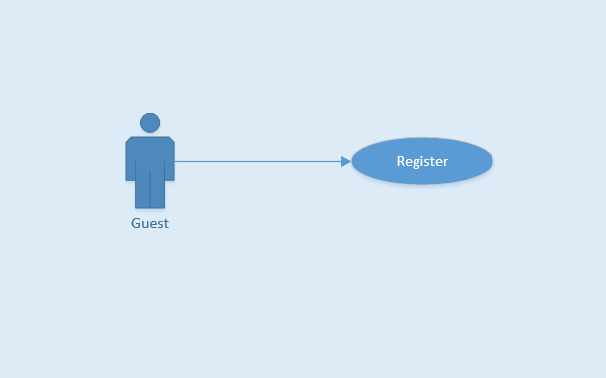

Figure 3‑2 Use-case UC-01

**Table 3‑2** Use-case UC-01 specification

|  |  |  |  |  |
| --- | --- | --- | --- | --- |
| **Use Case ID** | | | UC-01 | |
| **Use Name** | | | Register | |
| **Actor** | | | Guest | |
| **Description** | | | Guest can register account to have a valid user in system | |
| **Precondition** | | | Have a valid email address | |
| **Trigger** | | | Tap on “Đăng ký” button, “tick” icon and click on activation link | |
| **Post-Condition** | | | Rider account information is stored in database | |
| **Main flows** | | | | |
| **Step** | **Actor** | | **Action** | |
| 1 | Guest | | Tap on “Đăng ký” button on Login screen | |
| 2 | F-Taxi | | Display Login screen with the following fields:  - User Name/Email  - Password  - Password Again  - First Name  - Last Name  - Phone Number | |
| 3 | Guest | | Enter “Email”, “Mật khẩu”, “Nhập lại mật khẩu” , “Tên đệm”, “Tên ”, “Số ĐT” fields on the Register screen, then tap on “Đăng ký” icon. | |
| 4 | F-Taxi | | Validate the entered by Guest and show "Đăng ký thành công!" message, then display Login screen | |
|  |  | |  | |
| **Alternative flows** | | | | |
| **AT1** | | At step 4 in the main flows, if guest insert wrong “Nhập lại mật khẩu”, wrong email format, or keep mandatory field blank | | |
| **Step** | | **Actor** | | **Action** |
| 4.1 | | F-Taxi | | Display message to warning about wrong information and require enter again |
| **AT2** | | Display message that email has existed, and require guest to change email | | |
| **Step** | | **Actor** | | **Action** |
| 4.1 | | F-Taxi | | Display message that email has existed, and require guest to change email |
|  | |  | |  |

##### UC-02 Login

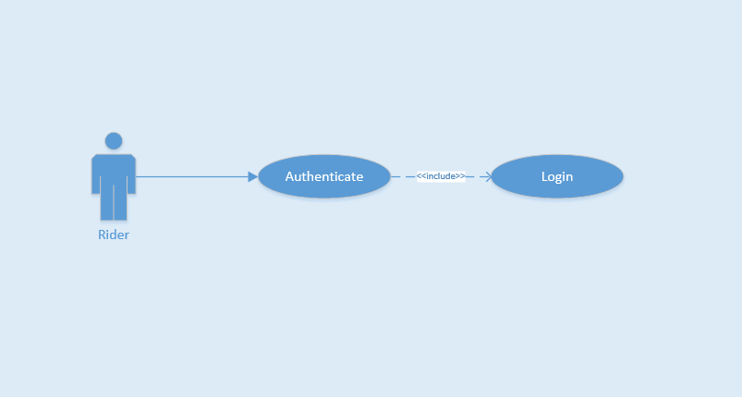

Figure 3‑3 Use-case UC-02

**Table 3‑3** Use-case UC-02 specification

|  |  |  |  |  |
| --- | --- | --- | --- | --- |
| **Use Case ID** | | | UC-02 | |
| **Use Name** | | | Login | |
| **Actor** | | | Rider | |
| **Description** | | | This function allows a Rider to be able to login the application when he/she have registered an account and his/her account is active | |
| **Precondition** | | | Start screen | |
| **Trigger** | | | Input email and password correctly in the right textbox then tap on “Đăng nhập” button | |
| **Post-Condition** | | | Login successfully | |
| **Main flows** | | | | |
| **Step** | **Actor** | | **Action** | |
| 1 | Rider | | Tap on “Bỏ qua để đăng nhập” button on Start screen | |
| 2 | F-Taxi | | Display Login screen with the following fields:  - Email  - “Mật khẩu”  - “Đăng nhập” button  - “Quên mật khẩu?” text block | |
| 3 | Rider | | Enter Email and “Mật khẩu” fields on the Login screen, then tap on “Đăng nhập” icon. | |
| 4 | F-Taxi | | Validate the entered Email and “Mật khẩu” and then display Home screen | |
|  |  | |  | |
| **Alternative flows** | | | | |
| **AT1** | | At step 4 in the main flows, if F-Taxi failed to validate username and password | | |
| **Step** | | **Actor** | | **Action** |
| 4.1 | | F-Taxi | | Display "Login" page with message "Email hoặc mật khẩu không đúng” |
|  | |  | |  |

##### UC- 03 Logout

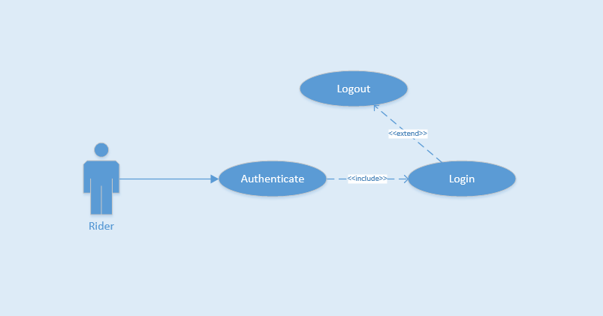

Figure 3‑4 Use-case UC-03

**Table 3‑4** Use-case UC-03 specification

|  |  |  |  |  |
| --- | --- | --- | --- | --- |
| **Use Case ID** | | | UC-03 | |
| **Use Name** | | | Logout | |
| **Actor** | | | Rider | |
| **Description** | | | This function allows a Rider to logout F-Taxi | |
| **Precondition** | | | Login | |
| **Trigger** | | | Tap on back button or tap on “Đăng xuất” icon in menu bar, and then tap “Có” or tap on “Đăng xuất” icon and then tap “Có” | |
| **Post-Condition** | | | Logout successfully | |
| **Main flows** | | | | |
| **Step** | **Actor** | | **Action** | |
| 1 | Rider | | On Home screen, tap on back button or tap on “Đăng xuất” icon in menu bar | |
| 2 | F-Taxi | | Display confirm message box with message “Bạn có muốn thoát không?” | |
| 3 | Rider | | Tap “Có” option on message box | |
| 4 | F-Taxi | | Log user out and display Login screen | |
|  |  | |  | |
| **Alternative flows** | | | | |
| **AT1** | | At step 3 in the main flows**,** if Rider tap “Không” option on message box | | |
| **Step** | | **Actor** | | **Action** |
| 3.1 | | F-Taxi | | Display "Login" page with message "Email hoặc mật khẩu không đúng” |
|  | |  | |  |

##### UC-04 Forget Password

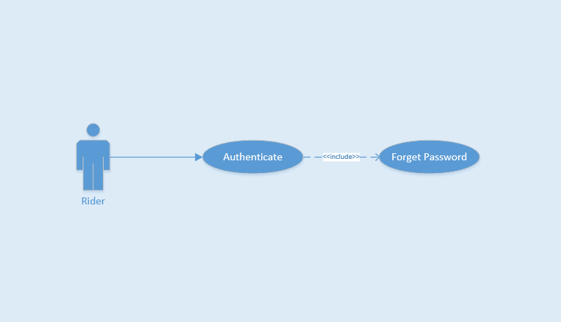

Figure 3‑5 Use-case UC-04

**Table 3‑5** Use-case UC-04 specification

|  |  |  |  |  |
| --- | --- | --- | --- | --- |
| **Use Case ID** | | | UC-04 | |
| **Use Name** | | | Forget Password | |
| **Actor** | | | Rider | |
| **Description** | | | The function allows an Rider create new password | |
| **Precondition** | | | Start app | |
| **Trigger** | | | Tap on “Quên mật khẩu?” text on Login screen | |
| **Post-Condition** | | | Reset password and create new password | |
| **Main flows** | | | | |
| **Step** | **Actor** | | **Action** | |
| 1 | Rider | | On Login screen, tap on “Quên mật khẩu?” text | |
| 2 | F-Taxi | | Display Forget Password screen | |
| 3 | Rider | | Enter email to Email field, tap on “Đặt lại mật khẩu” icon | |
| 4 | F-Taxi | | Show "Mật khẩu đã được gửi về hôm thư của bạn. Vui lòng kiếm tra và đăng nhập lại!" message and send email confirm for Rider | |
|  |  | |  | |
| **Alternative flows** | | | | |
| **AT1** | | At step 3 in the main flows**,** if Rider tap back button | | |
| **Step** | | **Actor** | | **Action** |
| 3.1 | | F-Taxi | | Display "Login" screen |
|  | |  | |  |

##### UC-05 View Profile

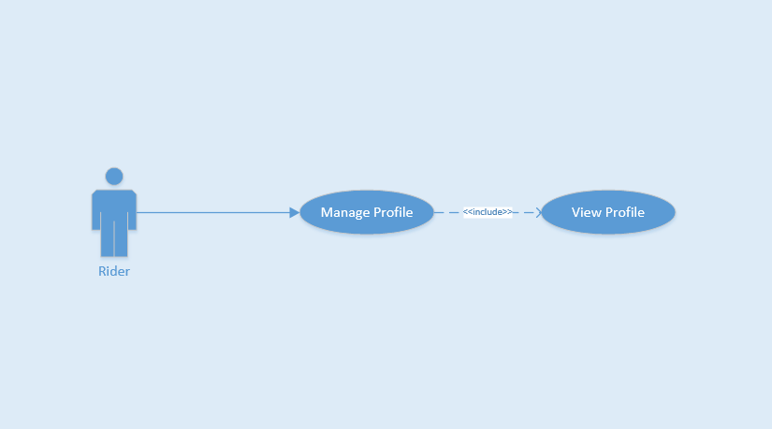

Figure 3‑6 Use-case UC-05

**Table 3‑6** Use-case UC-05 specification

|  |  |  |  |  |
| --- | --- | --- | --- | --- |
| **Use Case ID** | | | UC-05 | |
| **Use Name** | | | View Profile | |
| **Actor** | | | Rider | |
| **Description** | | | This function allows Rider view profile | |
| **Precondition** | | | Login and on Home Page Screen | |
| **Trigger** | | | Tap on top left menu and then tap on image or name of Rider | |
| **Post-Condition** | | | View successful | |
| **Main flows** | | | | |
| **Step** | **Actor** | | **Action** | |
| 1 | Rider | | In Home Page screen, tap on top left menu | |
| 2 | F-Taxi | | Show list left menu | |
| 3 | Rider | | Tap on image or name of Rider | |
| 4 | F-Taxi | | View successful | |
|  |  | |  | |
| **Alternative flows** | | | | |
| **AT1** | | At step 3 in the main flows**,** if Rider tap button back | | |
| **Step** | | **Actor** | | **Action** |
| 3.1 | | F-Taxi | | Back to Home Page Screen |
|  | |  | |  |

##### UC-06 Update profile

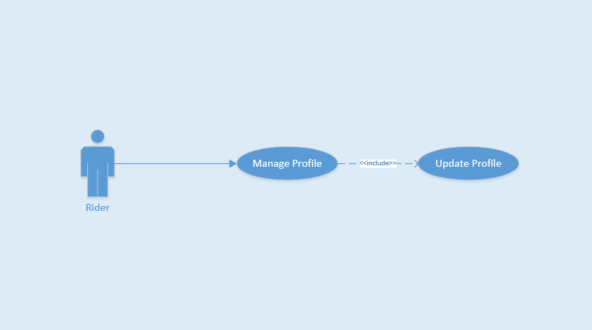

Figure 3‑7 Use-case UC-06

**Table 3‑7** Use-case UC-06 specification

|  |  |  |  |  |
| --- | --- | --- | --- | --- |
| **Use Case ID** | | | UC-06 | |
| **Use Name** | | | Update Profile | |
| **Actor** | | | Rider | |
| **Description** | | | The function allows Rider to change their profile | |
| **Precondition** | | | Login and on Home Page Screen | |
| **Trigger** | | | Tap on field want to change and update field | |
| **Post-Condition** | | | Updated successfully | |
| **Main flows** | | | | |
| **Step** | **Actor** | | **Action** | |
| 1 | Rider | | On Home Page screen, tap on avatar or name of menu bar | |
| 2 | F-Taxi | | Display Profile screen | |
| 3 | Rider | | Tap on field want to change and update field, then tap on “Lưu” button. | |
| 4 | F-Taxi | | Display message notice changed successfully. Stayed on Rider Profile page | |
| 5 | Rider | | Tap on pencil image to change home or work address | |
| 6 | F-Taxi | | Show Add Home Place or Add Work Place page | |
| 7 | Rider | | Enter address textbox and choose right place from suggest to auto complete address | |
| 8 | F-Taxi | | Show marker on maps. | |
| 9 | Rider | | Tap on “Lưu lại” button | |
| 10 | F-Taxi | | Display "Cập nhật thông tin cá nhân thành công!" message notice changed successfully | |
| **Alternative flows** | | | | |
| **AT1** | | At step 3 in the main flows**,** if Rider enter wrong information form | | |
| **Step** | | **Actor** | | **Action** |
| 3.1 | | F-Taxi | | Display message box remind Rider insert again |
|  | |  | |  |

##### UC-07 Change password

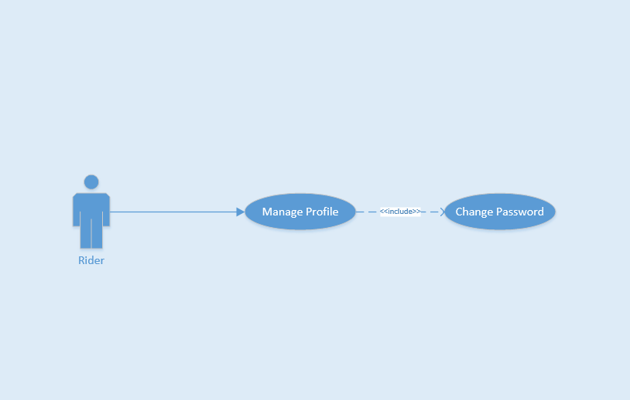

Figure 3‑8 Use-case UC-07

**Table 3‑8** Use-case UC-07 specification

|  |  |  |  |  |
| --- | --- | --- | --- | --- |
| **Use Case ID** | | | UC-07 | |
| **Use Name** | | | Change Password | |
| **Actor** | | | Rider | |
| **Description** | | | The function allows a Rider to change their password | |
| **Precondition** | | | Login and on Home Page Screen | |
| **Trigger** | | | Tap on “Đổi mật khẩu” text and enter all field to change, then tap on “Xác nhận thay đổi” icon. | |
| **Post-Condition** | | | Changed successfully | |
| **Main flows** | | | | |
| **Step** | **Actor** | | **Action** | |
| 1 | Rider | | On Home Page screen, tap on avatar or name on left menu | |
| 2 | F-Taxi | | Display Profile screen | |
| 3 | Rider | | Tap on “Đổi mật khẩu” text | |
| 4 | F-Taxi | | Display Change password screen with the following fields:  - “Mật khẩu cũ”  - “Mật khẩu mới”  - “Nhập lại mật khẩu mới” | |
| 5 | Rider | | Enter “Mật khẩu cũ”, “Mật khẩu mới”, “Nhập lại mật khẩu mới” field on Change Password screen and then tap on “Đặt lại mật khẩu”. | |
| 6 | F-Taxi | | Display a message box notice changed successfully | |
| **Alternative flows** | | | | |
| **AT1** | | At step 4 in the main flows**,** if Rider insert wrong format password | | |
| **Step** | | **Actor** | | **Action** |
| 4.1 | | F-Taxi | | Display message box remind Rider insert again |
|  | |  | |  |

##### UC-08 List favorite drivers

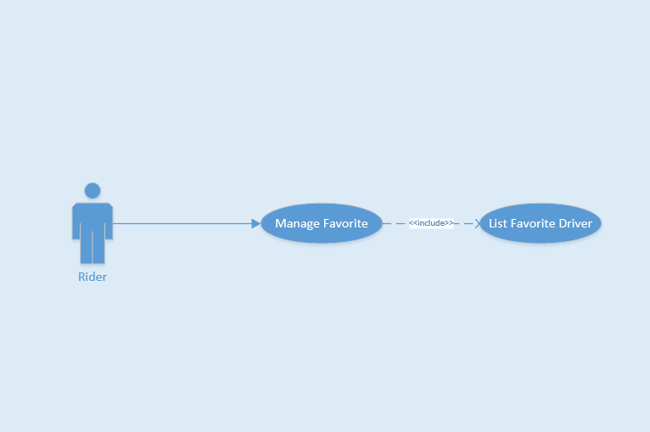

Figure 3‑9 Use-case UC-08

**Table 3‑9** Use-case UC-08 specification

|  |  |  |  |  |
| --- | --- | --- | --- | --- |
| **Use Case ID** | | | UC-08 | |
| **Use Name** | | | List Favorite Driver | |
| **Actor** | | | Rider | |
| **Description** | | | This function allows Rider show list favorite Driver | |
| **Precondition** | | | Login and on Home Page Screen | |
| **Trigger** | | | Tap on “Tài xế ưa thích” on left menu | |
| **Post-Condition** | | | Show list successful | |
| **Main flows** | | | | |
| **Step** | **Actor** | | **Action** | |
| 1 | Rider | | On Home Page screen, “Tài xế ưa thích” on left menu | |
| 2 | F-Taxi | | Show list favorite Driver | |
|  |  | |  | |
|  |  | |  | |
| **Alternative flows** | | | | |
| **AT1** | | At step 2 in the main flows**,** if Rider has no favorite Driver | | |
| **Step** | | **Actor** | | **Action** |
| 2.1 | | F-Taxi | | Show "Chưa có thông tin!" message |
|  | |  | |  |

##### UC-09 Add favorite driver

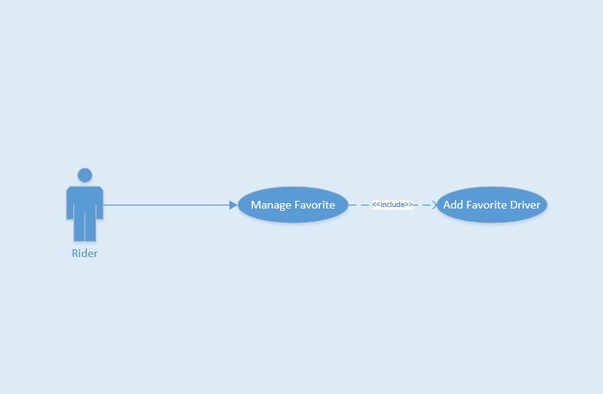

Figure 3‑10 Use-case UC-09

**Table 3‑10** Use-case UC-09 specification

|  |  |  |  |  |
| --- | --- | --- | --- | --- |
| **Use Case ID** | | | UC-09 | |
| **Use Name** | | | Add Favorite Driver | |
| **Actor** | | | Rider | |
| **Description** | | | This function allows Rider add favorite Driver | |
| **Precondition** | | | Finished Trip | |
| **Trigger** | | | Tap on Add Favorite button on detail bill | |
| **Post-Condition** | | | Add favorite Driver successful | |
| **Main flows** | | | | |
| **Step** | **Actor** | | **Action** | |
| 1 | F-Taxi | | Show detail bill on screen | |
| 2 | Rider | | Tap on “Thêm vào yêu thích” button | |
| 3 | F-Taxi | | Show "Bạn đã thêm thành công lái xe yêu thích!" and add favorite Driver successful | |
| 4 |  | |  | |
|  |  | |  | |
| **Alternative flows** | | | | |
|  | |  | | |
| **Step** | | **Actor** | | **Action** |
|  | |  | |  |
|  | |  | |  |

##### UC-10 Delete favorite driver

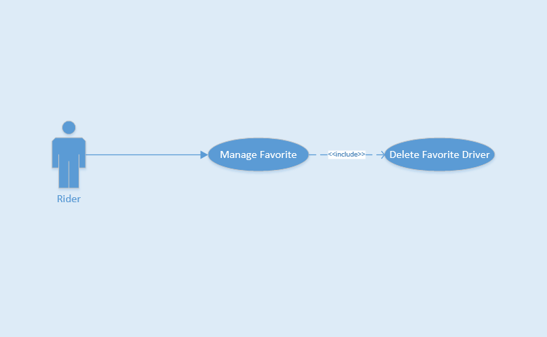

Figure 3‑11 Use-case UC-10

**Table 3‑11** Use-case UC-10 specification

|  |  |  |  |  |
| --- | --- | --- | --- | --- |
| **Use Case ID** | | | UC-10 | |
| **Use Name** | | | Delete Favorite Driver | |
| **Actor** | | | Rider | |
| **Description** | | | This function allows Rider delete favorite Driver | |
| **Precondition** | | | Login and on Home Page Screen | |
| **Trigger** | | | Tap on favorite Driver and tap on “Xóa khỏi danh sách” button | |
| **Post-Condition** | | | Delete favorite Driver Successful | |
| **Main flows** | | | | |
| **Step** | **Actor** | | **Action** | |
| 1 | Rider | | On Home Page screen, “Tài xế ưa thích” on left menu | |
| 2 | F-Taxi | | Show list favorite Driver | |
| 3 | Rider | | Choose Driver and tap on, then tap on “Xóa khỏi danh sách” | |
| 4 | F-Taxi | | Delete favorite Driver successful | |
|  |  | |  | |
| **Alternative flows** | | | | |
| **AT1** | | At step 3 in the main flows**,** if Rider tap on “ Hủy” button | | |
| **Step** | | **Actor** | | **Action** |
| 3.1 | | F-Taxi | | Back to List Favorite Driver page |
|  | |  | |  |

##### UC-11 Call favorite driver

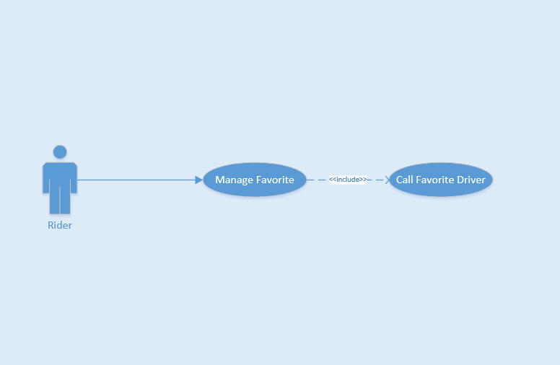

Figure 3‑12 Use-case UC-11

**Table 3‑12** Use-case UC-11 specification

|  |  |  |  |  |
| --- | --- | --- | --- | --- |
| **Use Case ID** | | | UC-11 | |
| **Use Name** | | | Call Favorite Driver | |
| **Actor** | | | Rider | |
| **Description** | | | This function allows Rider call favorite Driver instantly | |
| **Precondition** | | | Login and on Home Page Screen | |
| **Trigger** | | | Tap on favorite Driver and tap on “Gọi tài xế” button | |
| **Post-Condition** | | | Call favorite Driver successful | |
| **Main flows** | | | | |
| **Step** | **Actor** | | **Action** | |
| 1 | Rider | | On Home Page screen, tap on “Tài xế ưa thích” on left menu | |
| 2 | F-Taxi | | Show list favorite Driver | |
| 3 | Rider | | Choose Driver and tap on, then tap on “Gọi tài xế” | |
| 4 | F-Taxi | | Call favorite Driver successful | |
|  |  | |  | |
| **Alternative flows** | | | | |
| **AT1** | | At step 3 in the main flows**,** if Rider tap on “ Hủy” button | | |
| **Step** | | **Actor** | | **Action** |
| 3.1 | | F-Taxi | | Back to List Favorite Driver page |
|  | |  | |  |

##### UC-12 Find lost asset

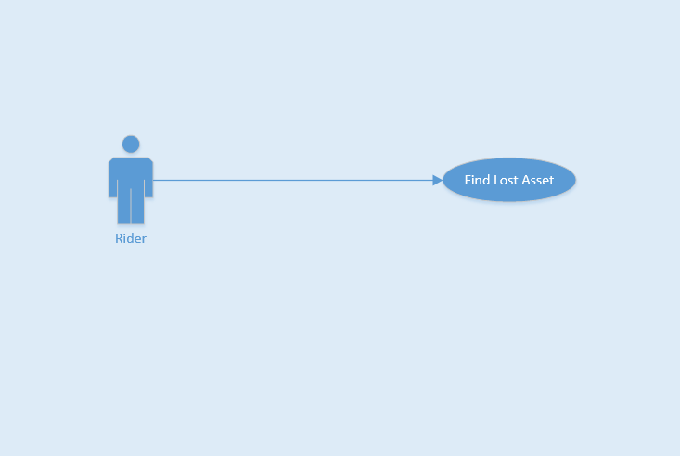

Figure 3‑13 Use-case UC-12

**Table 3‑13** Use-case UC-12 specification

|  |  |  |  |  |
| --- | --- | --- | --- | --- |
| **Use Case ID** | | | UC-12 | |
| **Use Name** | | | Find Lost Asset | |
| **Actor** | | | Rider | |
| **Description** | | | This function allows Rider find lost asset after finished trip | |
| **Precondition** | | | Finished Trip and on Home Page screen | |
| **Trigger** | | | Tap on trip and enter message , then send the message | |
| **Post-Condition** | | | Send message successful | |
| **Main flows** | | | | |
| **Step** | **Actor** | | **Action** | |
| 1 | Rider | | On Home Page screen, tap on “Lịch sử chuyến đi” on left menu | |
| 2 | F-Taxi | | Show list complete trip | |
| 3 | Rider | | Choose a trip and tap on, then tap on “Báo mất đồ” button | |
| 4 | F-Taxi | | Show textbox field | |
| 5 | Rider | | Enter textbox field and tap on “Gửi” button | |
| 6 | F-Taxi | | Send message successfull | |
| **Alternative flows** | | | | |
| **AT1** | | At step 5 in the main flows**,** if Rider tap on “ Hủy” button | | |
| **Step** | | **Actor** | | **Action** |
| 5.1 | | F-Taxi | | Back to List Complete Trip page |
|  | |  | |  |

##### UC-13 Send application feedback

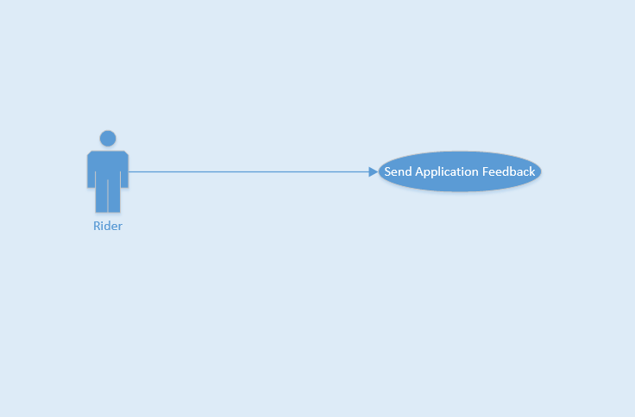

Figure 3‑14 Use-case UC-13

**Table 3‑14** Use-case UC-13 specification

|  |  |  |  |  |
| --- | --- | --- | --- | --- |
| **Use Case ID** | | | UC-13 | |
| **Use Name** | | | Send Application Feedback | |
| **Actor** | | | Rider | |
| **Description** | | | This function allows Rider send feedback of application | |
| **Precondition** | | | On Home Page screen | |
| **Trigger** | | | Tap on feedback and enter textbox field | |
| **Post-Condition** | | | Send feedback successful | |
| **Main flows** | | | | |
| **Step** | **Actor** | | **Action** | |
| 1 | Rider | | On Home Page screen, tap on “Phản hồi” on left menu | |
| 2 | F-Taxi | | Show two textbox field | |
| 3 | Rider | | Enter “Tiêu đề” and “Nội dung” textbox field and tap on “Gửi” button | |
| 4 | F-Taxi | | Send feedback successfull | |
| **Alternative flows** | | | | |
| **AT1** | | At step 3 in the main flows**,** if Rider tap on back button | | |
| **Step** | | **Actor** | | **Action** |
| 3.1 | | F-Taxi | | Back to Home Page screen |
|  | |  | |  |

##### UC-14 Call taxi center

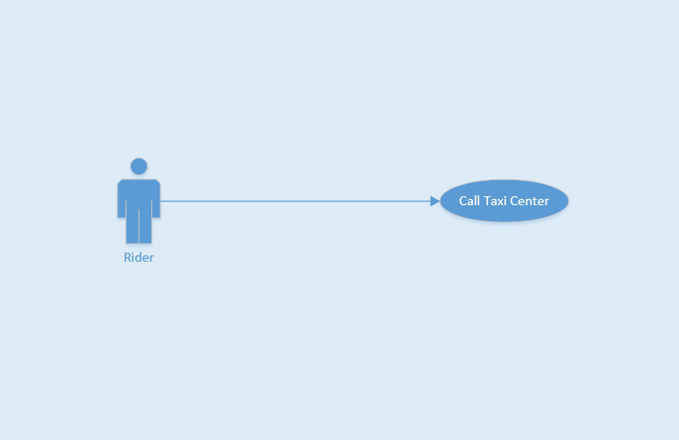

Figure 3‑15 Use-case UC-14

**Table 3‑15** Use-case UC-14 specification

|  |  |  |  |  |
| --- | --- | --- | --- | --- |
| **Use Case ID** | | | UC-14 | |
| **Use Name** | | | Call Taxi Center | |
| **Actor** | | | Rider | |
| **Description** | | | This function allows Rider call taxi center when around without vehicle | |
| **Precondition** | | | On Home Page screen | |
| **Trigger** | | | Tap on red marker and choose the taxi company | |
| **Post-Condition** | | | Call taxi center successful | |
| **Main flows** | | | | |
| **Step** | **Actor** | | **Action** | |
| 1 | Rider | | On Home Page screen, tap on red marker name “Gọi hãng” on map screen | |
| 2 | F-Taxi | | Show list taxi companies | |
| 3 | Rider | | Choose taxi company and tap on logo taxi company to call | |
| 4 | F-Taxi | | Call taxi center successful | |
| **Alternative flows** | | | | |
| **AT1** | | At step 3 in the main flows**,** if Rider want search name of taxi company | | |
| **Step** | | **Actor** | | **Action** |
| 3.1 | | Rider | | Enter character into search field |
| 3.2 | | F-Taxi | | Return result of search for Rider |

##### UC-15 Create Trip

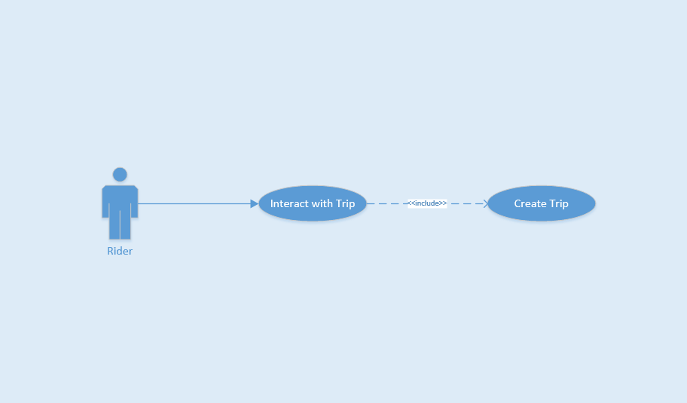

Figure 3‑16 Use-case UC-15

**Table 3‑16** Use-case UC-15 specification

|  |  |  |  |  |
| --- | --- | --- | --- | --- |
| **Use Case ID** | | | UC-15 | |
| **Use Name** | | | Create Trip | |
| **Actor** | | | Rider | |
| **Description** | | | This function allows Rider create a trip | |
| **Precondition** | | | Login and on Home Page screen | |
| **Trigger** | | | Using finger to select or enter on field search address to pick up, then tap to call taxi | |
| **Post-Condition** | | | Created Trip | |
| **Main flows** | | | | |
| **Step** | **Actor** | | **Action** | |
| 1 | Rider | | Using finger to select or enter on field search address to pick up | |
| 2 | F-Taxi | | Show Trip bar include Driver information and open price | |
| 3 |  | |  | |
| 4 |  | |  | |
| 5 | Rider | | Tap on “Yêu cầu Taxi” button | |
| 6 | F-Taxi | | Show "Vui lòng đợi..." message, Driver accepted, then show "Xe đang tới..." message and Driver started trip, show "Chúc bạn một chuyến đi vui vẻ" message and created trip | |
| **Alternative flows** | | | | |
| **AT1** | | At step 1 in the main flows**,** if Rider enter wrong address field | | |
| **Step** | | **Actor** | | **Action** |
| 1.1 | | F-Taxi | | Show ""Địa chỉ không hợp lệ, vui lòng thử lại!"" message on screen |
|  | |  | |  |
| **AT2** | | At step 1 in the main flows**,** if around has no taxi | | |
| **Step** | | **Actor** | | **Action** |
| 1.2 | | F-Taxi | | Show "Không có taxi nào gần đây, vui lòng thử lại sau!" message on screen |
|  | |  | |  |
|  | |  | |  |
| **AT3** | | At step 4 in the main flows**,** if Driver rejected request from Rider | | |
| **Step** | | **Actor** | | **Action** |
| 4.1 | | F-Taxi | | Show "Yêu cầu bị hủy bỏ!" message on screen |
|  | |  | |  |
|  | |  | |  |

##### UC-16 Cancel Trip

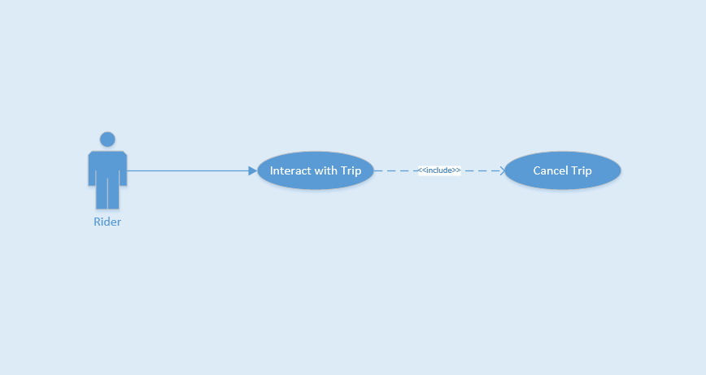

Figure 3‑17 Use-case UC-16

**Table 3‑17** Use-case UC-16 specification

|  |  |  |  |  |
| --- | --- | --- | --- | --- |
| **Use Case ID** | | | UC-16 | |
| **Use Name** | | | Cancel Trip | |
| **Actor** | | | Rider | |
| **Description** | | | This function allows Rider cancel a trip | |
| **Precondition** | | | Login and on Home Page screen | |
| **Trigger** | | | Using finger to select or enter on field search address to pick up, then tap to call taxi. During time wait taxi response. Tap cancel | |
| **Post-Condition** | | | Canceled Trip | |
| **Main flows** | | | | |
| **Step** | **Actor** | | **Action** | |
| 1 | Rider | | Using finger to select or enter on field search address to pick up | |
| 2 | F-Taxi | | Show Trip bar include Driver information and open price | |
| 3 | Rider | | Tap on “Yêu cầu Taxi” button | |
| 4 | F-Taxi | | Created Trip | |
| 5 | Rider | | Tap on ”Hủy” red button | |
| 6 | F-Taxi | | Show "Yêu cầu bị hủy bỏ!" message, Canceled Trip | |
| **Alternative flows** | | | | |
|  | |  | | |
| **Step** | | **Actor** | | **Action** |
|  | |  | |  |
|  | |  | |  |

##### UC-17 List completed trip

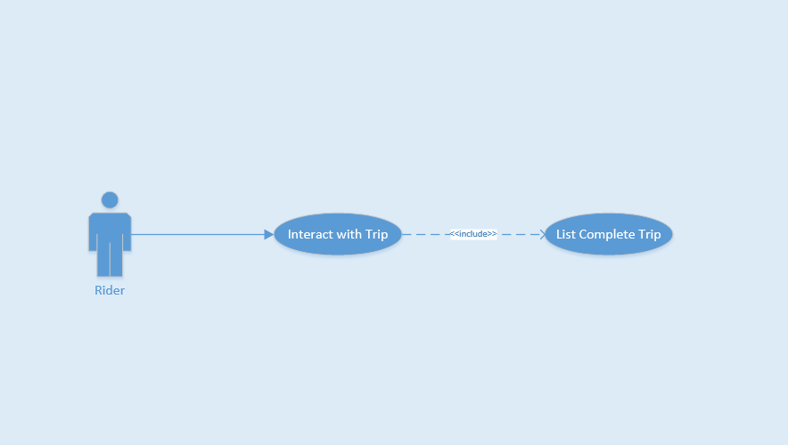

Figure 3‑18 Use-case UC-17

**Table 3‑18** Use-case UC-17 specification

|  |  |  |  |  |
| --- | --- | --- | --- | --- |
| **Use Case ID** | | | UC-17 | |
| **Use Name** | | | List Complete Trip | |
| **Actor** | | | Rider | |
| **Description** | | | This function allows Rider view list completed trip | |
| **Precondition** | | | On Home Page screen | |
| **Trigger** | | | Tap on list complete trip button on left menu | |
| **Post-Condition** | | | Show list complete trip successful | |
| **Main flows** | | | | |
| **Step** | **Actor** | | **Action** | |
| 1 | Rider | | On Home Page Screen, them tap on “Lịch sử chuyến đi” on left menu | |
| 2 | F-Taxi | | Show list complete trip successful | |
| 3 | Rider | | Tap on “Xem chi tiêt” | |
| 4 | F-Taxi | | Show detail trip | |
| **Alternative flows** | | | | |
| **AT1** | | At step 2 in the main flows, if Rider have no trip before | | |
| **Step** | | **Actor** | | **Action** |
| 2.1 | | F-Taxi | | Show "Bạn chưa có chuyến đi nào cả!" message |
|  | |  | |  |

##### UC-18 View bill detail

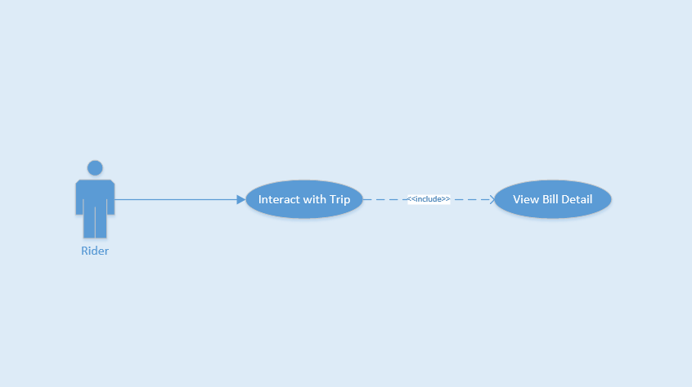

Figure 3‑19 Use-case UC-18

**Table 3‑19** Use-case UC-18 specification

|  |  |  |  |  |
| --- | --- | --- | --- | --- |
| **Use Case ID** | | | UC-18 | |
| **Use Name** | | | View Bill Detail | |
| **Actor** | | | Rider | |
| **Description** | | | This function allows Rider view bill detail of trip | |
| **Precondition** | | | Finished Trip | |
| **Trigger** | | | Tap on “Kết thúc” button | |
| **Post-Condition** | | | Show bill detail successful | |
| **Main flows** | | | | |
| **Step** | **Actor** | | **Action** | |
| 1 | Driver | | Tap on “Hoàn thành chuyến đi” button | |
| 2 | F-Taxi | | Show bill detail on screen Rider and Driver | |
|  |  | |  | |
|  |  | |  | |
| **Alternative flows** | | | | |
|  | |  | | |
| **Step** | | **Actor** | | **Action** |
|  | |  | |  |
|  | |  | |  |

##### UC-19 Rate driver

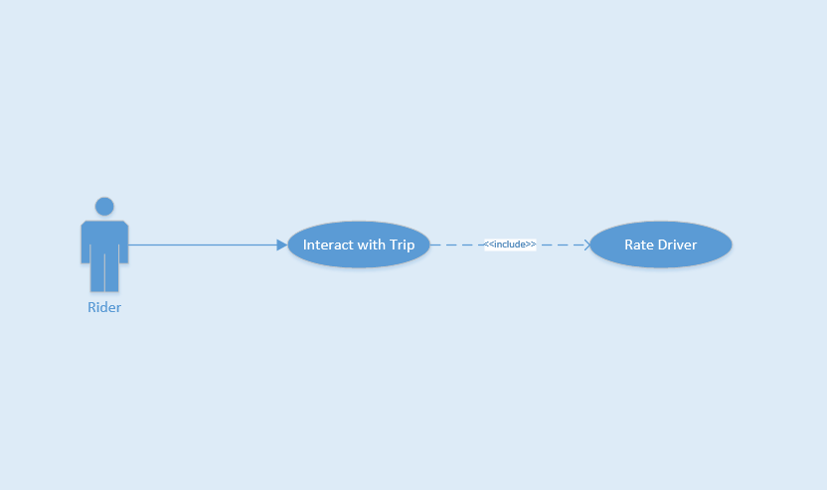

Figure 3‑20 Use-case UC-19

**Table 3‑20** Use-case UC-19 specification

|  |  |  |  |  |
| --- | --- | --- | --- | --- |
| **Use Case ID** | | | UC-19 | |
| **Use Name** | | | Rate Driver | |
| **Actor** | | | Rider | |
| **Description** | | | This function allows Rider rate Driver after every trip | |
| **Precondition** | | | Finished Trip | |
| **Trigger** | | | Using finger choose from 1 to 5 star | |
| **Post-Condition** | | | Rate Driver completed | |
| **Main flows** | | | | |
| **Step** | **Actor** | | **Action** | |
| 1 | F-Taxi | | Show bill detail after finished trip | |
| 2 | Rider | | Using finger choose from 1 to 5 star | |
| 3 | F-Taxi | | Rate Driver completed | |
| 4 | Rider | |  | |
| **Alternative flows** | | | | |
|  | |  | | |
| **Step** | | **Actor** | | **Action** |
|  | |  | |  |
|  | |  | |  |

#### Driver Requirement



Figure 3‑21 The Driver Use-case diagram

**Table 3‑21** Driver Use-cases

|  |  |  |  |  |
| --- | --- | --- | --- | --- |
| **Use Case ID** | **Actor** | **Group of function** | **Name** | **Note** |
| UC-20 | Driver | Authenticate | Login |  |
| UC-21 | Logout |  |
| UC-22 | Forget Password |  |
| UC-23 | View Profile |  |
| UC-24 | Manage Profile | Update Profile |  |
| UC-25 | Change Password |  |
| UC-26 | Company Info |  |
| UC-27 |  | Notification Lost Asset |  |
| UC-28 |  | Change Status |  |
| UC-29 | Interact with Trip | Accept Trip |  |
| UC-30 | Reject Trip |  |
| UC-31 | Start Trip |  |
| UC-32 | Cancel Trip |  |
| UC-33 | Complete Trip |  |
| UC-34 | View Bill Detail |  |

##### UC-20 Login

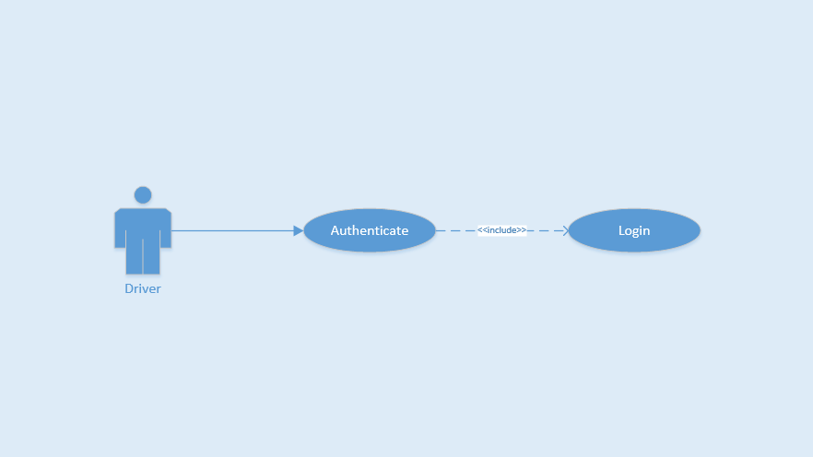

Figure 3‑22 Use-case UC-20

**Table 3‑22** Use-case UC-20 specification

|  |  |  |  |  |
| --- | --- | --- | --- | --- |
| **Use Case ID** | | | UC-20 | |
| **Use Name** | | | Login | |
| **Actor** | | | Driver | |
| **Description** | | | This function allows a Rider to be able to login the application when he/she have registered an account and his/her account is active | |
| **Precondition** | | | Start screen | |
| **Trigger** | | | Input email and password correctly in the right textbox then tap on “Đăng nhập” button | |
| **Post-Condition** | | | Login successfully | |
| **Main flows** | | | | |
| **Step** | **Actor** | | **Action** | |
| 1 | Driver | | Tap on “Bỏ qua để đăng nhập” button on Start screen | |
| 2 | F-Taxi | | Display Login screen with the following fields:  - Email  - “Mật khẩu”  - “Đăng nhập” button  - “Quên mật khẩu?” text block | |
| 3 | Driver | | Enter Email and “Mật khẩu” fields on the Login screen, then tap on “Đăng nhập” icon. | |
| 4 | F-Taxi | | Validate the entered Email and “Mật khẩu” and then display Home screen | |
|  |  | |  | |
| **Alternative flows** | | | | |
| **AT1** | | At step 4 in the main flows, if F-Taxi failed to validate username and password | | |
| **Step** | | **Actor** | | **Action** |
| 4.1 | | F-Taxi | | Display "Login" page with message "Email hoặc mật khẩu không đúng” |
|  | |  | |  |

##### UC-21 Logout

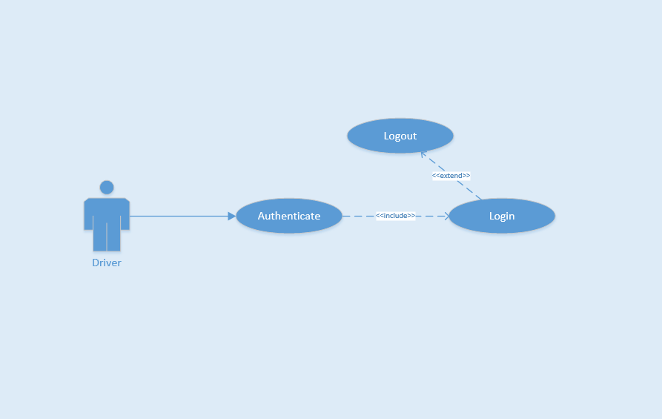

Figure 3‑23 Use-case UC-21

**Table 3‑23** Use-case UC-21 specification

|  |  |  |  |  |
| --- | --- | --- | --- | --- |
| **Use Case ID** | | | UC-21 | |
| **Use Name** | | | Logout | |
| **Actor** | | | Driver | |
| **Description** | | | This function allows a Driver to logout F-Taxi | |
| **Precondition** | | | Login | |
| **Trigger** | | | Tap on back button or tap on “Đăng xuất” icon in menu bar, and then tap “Có” or tap on “Đăng xuất” icon and then tap “Có” | |
| **Post-Condition** | | | Logout successfully | |
| **Main flows** | | | | |
| **Step** | **Actor** | | **Action** | |
| 1 | Driver | | On Home screen, tap on back button or tap on “Đăng xuất” icon in menu bar | |
| 2 | F-Taxi | | Display confirm message box with message “Bạn có muốn thoát không?” | |
| 3 | Driver | | Tap “Có” option on message box | |
| 4 | F-Taxi | | Log user out and display Login screen | |
|  |  | |  | |
| **Alternative flows** | | | | |
| **AT1** | | At step 3 in the main flows**,** if Driver tap “Không” option on message box | | |
| **Step** | | **Actor** | | **Action** |
| 3.1 | | F-Taxi | | Display "Login" page with message "Email hoặc mật khẩu không đúng” |
|  | |  | |  |

##### UC-22 Forget password

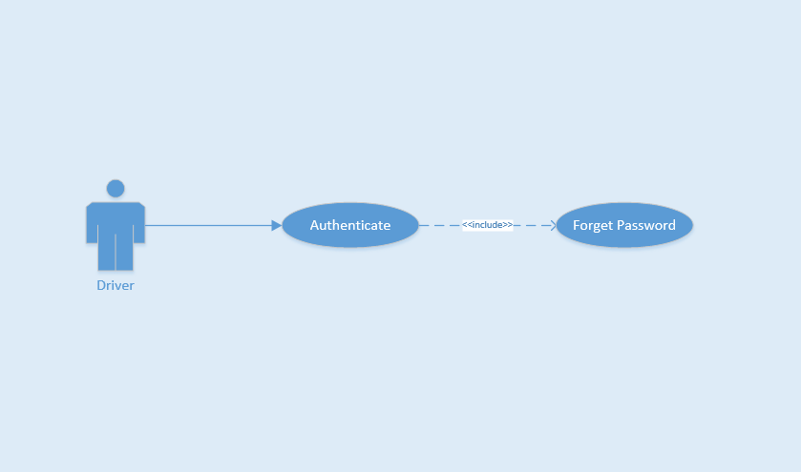

Figure 3‑24 Use-case UC-22

**Table 3‑24** Use-case UC-22 specification

|  |  |  |  |  |
| --- | --- | --- | --- | --- |
| **Use Case ID** | | | UC-22 | |
| **Use Name** | | | Forget Password | |
| **Actor** | | | Driver | |
| **Description** | | | The function allows an Driver create new password | |
| **Precondition** | | | Start app | |
| **Trigger** | | | Tap on “Quên mật khẩu?” text on Login screen | |
| **Post-Condition** | | | Reset password and create new password | |
| **Main flows** | | | | |
| **Step** | **Actor** | | **Action** | |
| 1 | Driver | | On Login screen, tap on “Quên mật khẩu?” text | |
| 2 | F-Taxi | | Display Forget Password screen | |
| 3 | Driver | | Enter email to Email field, tap on “Đặt lại mật khẩu” icon | |
| 4 | F-Taxi | | Send email confirm for Driver | |
|  |  | |  | |
| **Alternative flows** | | | | |
| **AT1** | | At step 3 in the main flows**,** if Driver tap back button | | |
| **Step** | | **Actor** | | **Action** |
| 3.1 | | F-Taxi | | Display "Login" screen |
|  | |  | |  |

##### UC-23 View profile

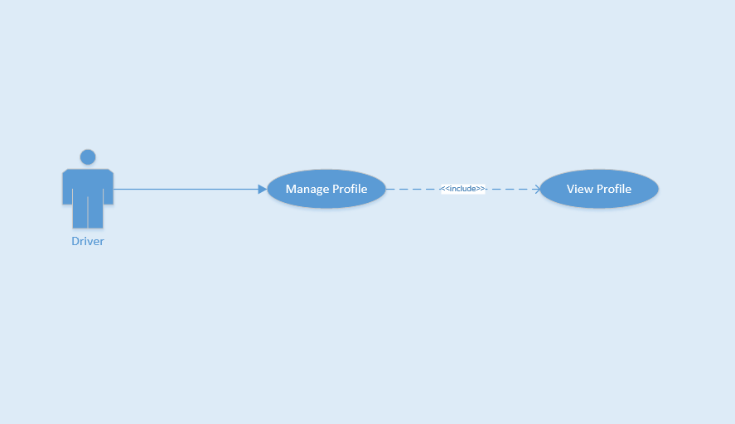

Figure 3‑25 Use-case UC-23

**Table 3‑25** Use-case UC-23 specification

|  |  |  |  |  |
| --- | --- | --- | --- | --- |
| **Use Case ID** | | | UC-23 | |
| **Use Name** | | | View Profile | |
| **Actor** | | | Driver | |
| **Description** | | | This function allows Driver view profile | |
| **Precondition** | | | Login and on Home Page Screen | |
| **Trigger** | | | Tap on top left menu and then tap on image or name of Driver | |
| **Post-Condition** | | | View successful | |
| **Main flows** | | | | |
| **Step** | **Actor** | | **Action** | |
| 1 | Rider | | In Home Page screen, tap on top left menu | |
| 2 | F-Taxi | | Show list left menu | |
| 3 | Driver | | Tap on image or name of Driver | |
| 4 | F-Taxi | | View successful | |
|  |  | |  | |
| **Alternative flows** | | | | |
| **AT1** | | At step 3 in the main flows**,** if Driver tap button back | | |
| **Step** | | **Actor** | | **Action** |
| 3.1 | | F-Taxi | | Back to Home Page Screen |
|  | |  | |  |

##### UC-24 Update profile

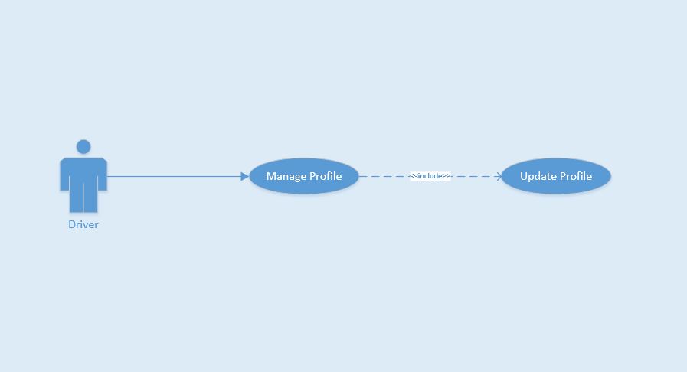

Figure 3‑26 Use-case UC-24

**Table 3‑26** Use-case UC-24 specification

|  |  |  |  |  |
| --- | --- | --- | --- | --- |
| **Use Case ID** | | | UC-24 | |
| **Use Name** | | | Update Profile | |
| **Actor** | | | Driver | |
| **Description** | | | The function allows Driver to change their profile | |
| **Precondition** | | | Login and on Home Page Screen | |
| **Trigger** | | | Tap on field want to change and update field | |
| **Post-Condition** | | | Updated successfully | |
| **Main flows** | | | | |
| **Step** | **Actor** | | **Action** | |
| 1 | Driver | | On Home Page screen, tap on avatar or name of menu bar | |
| 2 | F-Taxi | | Display Profile screen | |
| 3 | Driver | | Tap on field want to change and update field, then tap on “Lưu” button. | |
| 4 | F-Taxi | | Display message notice changed successfully. Stayed on Driver Profile page | |
| 5 | Driver | | Tap on pencil image to change home or work address | |
| 6 | F-Taxi | | Show Add Home Place screen | |
| 7 | Driver | | Enter address textbox and choose right place from suggest to auto complete address | |
| 8 | F-Taxi | | Show marker on maps. | |
| 9 | Driver | | Tap on “Lưu lại” button | |
| 10 | F-Taxi | | Display message notice changed successfully | |
| **Alternative flows** | | | | |
| **AT1** | | At step 3 in the main flows**,** if Driver enter wrong information form | | |
| **Step** | | **Actor** | | **Action** |
| 3.1 | | F-Taxi | | Display message box remind Driver insert again |
|  | |  | |  |

##### UC-25 Change password

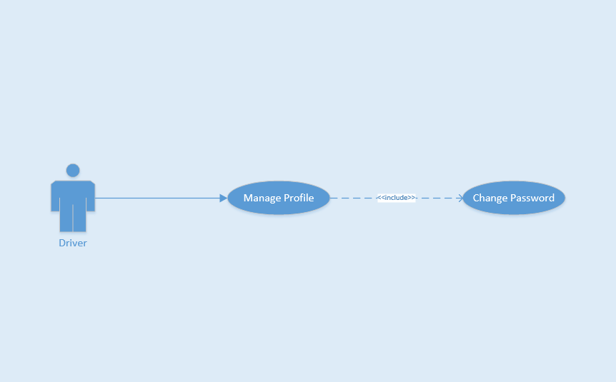

Figure 3‑27 Use-case UC-25

**Table 3‑27** Use-case UC-25 specification

|  |  |  |  |  |
| --- | --- | --- | --- | --- |
| **Use Case ID** | | | UC-25 | |
| **Use Name** | | | Change Password | |
| **Actor** | | | Driver | |
| **Description** | | | The function allows a Driver to change their password | |
| **Precondition** | | | Login and on Home Page Screen | |
| **Trigger** | | | Tap on “Đổi mật khẩu” text and enter all field to change, then tap on “Xác nhận thay đổi” icon. | |
| **Post-Condition** | | | Changed successfully | |
| **Main flows** | | | | |
| **Step** | **Actor** | | **Action** | |
| 1 | Driver | | On Home Page screen, tap on avatar or name on left menu | |
| 2 | F-Taxi | | Display Profile screen | |
| 3 | Driver | | Tap on “Đổi mật khẩu” text | |
| 4 | F-Taxi | | Display Change password screen with the following fields:  - “Mật khẩu cũ”  - “Mật khẩu mới”  - “Nhập lại mật khẩu mới” | |
| 5 | Driver | | Enter “Mật khẩu cũ”, “Mật khẩu mới”, “Nhập lại mật khẩu mới” field on Change Password screen and then tap on “Đặt lại mật khẩu”. | |
| 6 | F-Taxi | | Display a message box notice changed successfully | |
| **Alternative flows** | | | | |
| **AT1** | | At step 4 in the main flows**,** if Driver insert wrong format pasword | | |
| **Step** | | **Actor** | | **Action** |
| 4.1 | | F-Taxi | | Display message box remind Driver insert again |
|  | |  | |  |

##### UC-26 View company information

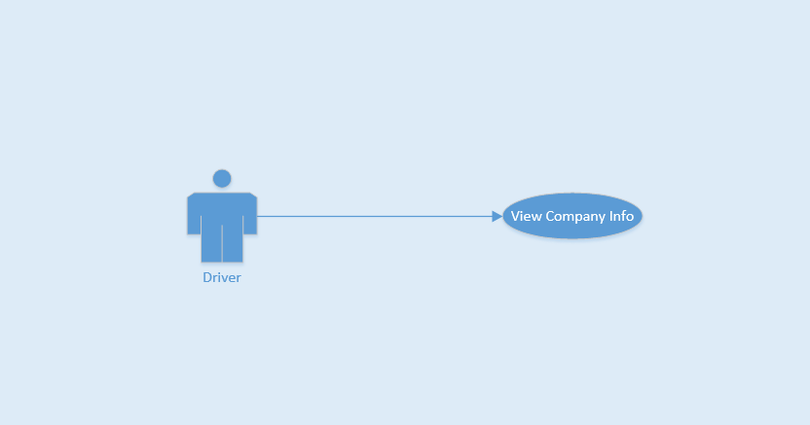

Figure 3‑28 Use-case UC-26

**Table 3‑28** Use-case UC-26 specification

|  |  |  |  |  |
| --- | --- | --- | --- | --- |
| **Use Case ID** | | | UC-26 | |
| **Use Name** | | | View Company Info | |
| **Actor** | | | Driver | |
| **Description** | | | This function allows Rider view company info | |
| **Precondition** | | | Login and on Home Page screen | |
| **Trigger** | | | Tap on company info | |
| **Post-Condition** | | | View successful | |
| **Main flows** | | | | |
| **Step** | **Actor** | | **Action** | |
| 1 | Driver | | On Home Page screen, tap on “Thông tin công ty” on left menu | |
| 2 | F-Taxi | | Show information of company Driver | |
| 3 | Driver | | View successfully | |
|  |  | |  | |
| **Alternative flows** | | | | |
|  | |  | | |
| **Step** | | **Actor** | | **Action** |
|  | |  | |  |
|  | |  | |  |

##### UC-27 Notify lost asset

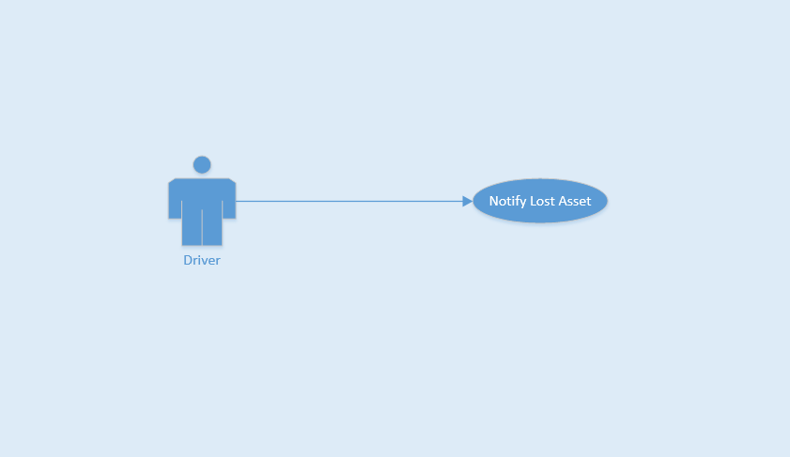

Figure 3‑29 Use-case UC-27

**Table 3‑29** Use-case UC-27 specification

|  |  |  |  |  |
| --- | --- | --- | --- | --- |
| **Use Case ID** | | | UC-27 | |
| **Use Name** | | | Notify Lost Asset | |
| **Actor** | | | Driver | |
| **Description** | | | This function allows Rider | |
| **Precondition** | | | On Home Page screen | |
| **Trigger** | | | Tap on list complete trip button on left menu, and tap on trip lost asset | |
| **Post-Condition** | | | Send message successful | |
| **Main flows** | | | | |
| **Step** | **Actor** | | **Action** | |
| 1 | Driver | | On Home Page screen, tap on “Lịch sử của tôi” on left menu | |
| 2 | F-Taxi | | Show list complete trip | |
| 3 | Driver | | Choose a trip and tap on, then tap on “Báo nhặt được đồ” button | |
| 4 | F-Taxi | | Show textbox field | |
| 5 | Driver | | Enter textbox field and tap on “Gửi” button | |
| 6 | F-Taxi | | Send message successful | |
| **Alternative flows** | | | | |
|  | |  | | |
| **Step** | | **Actor** | | **Action** |
|  | |  | |  |
|  | |  | |  |

##### UC-28 Change status

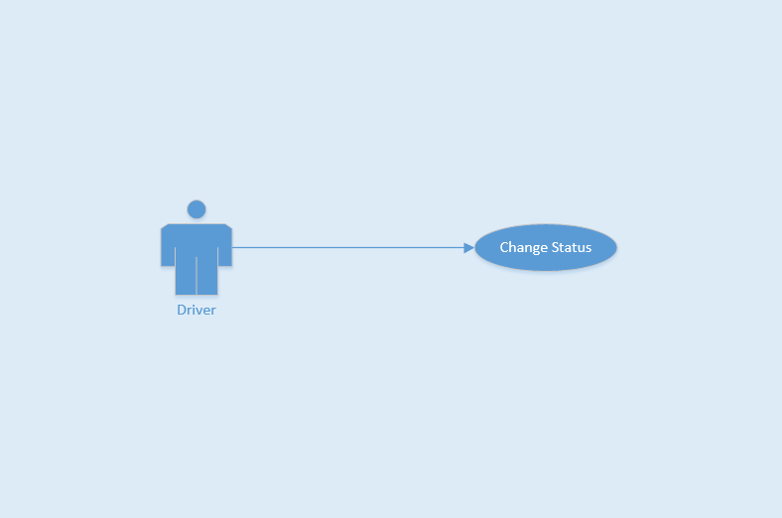

Figure 3‑30 Use-case UC-28

**Table 3‑30** Use-case UC-28 specification

|  |  |  |  |  |
| --- | --- | --- | --- | --- |
| **Use Case ID** | | | UC-28 | |
| **Use Name** | | | Change Status | |
| **Actor** | | | Driver | |
| **Description** | | | This function allows Driver change status not available when Driver want off time work day | |
| **Precondition** | | | Login and on Home Page screen | |
| **Trigger** | | | Tap on change status button or logout application | |
| **Post-Condition** | | | Changed Status | |
| **Main flows** | | | | |
| **Step** | **Actor** | | **Action** | |
| 1 | Driver | | On Home Page screen | |
| 2 | F-Taxi | | Tap on “Nhấn để chuyển qua trạng thái nghỉ” button or logout application | |
| 3 | Driver | | Changed Status | |
|  |  | |  | |
| **Alternative flows** | | | | |
|  | |  | | |
| **Step** | | **Actor** | | **Action** |
|  | |  | |  |
|  | |  | |  |

##### UC-29 Accept trip

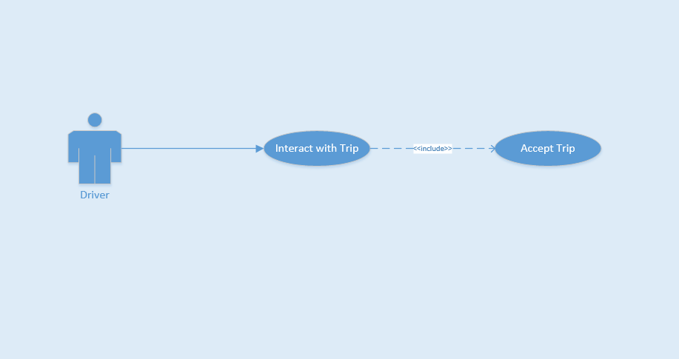

Figure 3‑31 Use-case UC-29

**Table 3‑31** Use-case UC-29 specification

|  |  |  |  |  |
| --- | --- | --- | --- | --- |
| **Use Case ID** | | | UC-29 | |
| **Use Name** | | | Accept Trip | |
| **Actor** | | | Driver | |
| **Description** | | | This function allows Driver accepted request from Rider call | |
| **Precondition** | | | Login | |
| **Trigger** | | | Dialog box show up and Driver tap on “Đồng ý” button | |
| **Post-Condition** | | | Driver accepted trip and pick up Rider | |
| **Main flows** | | | | |
| **Step** | **Actor** | | **Action** | |
| 1 | F-Taxi | | Send notification and request from Rider to Driver, show dialog box | |
| 2 | Driver | | Tap on “Đồng ý ” button | |
| 3 | F-Taxi | | Driver accepted trip and pick up Rider | |
|  |  | |  | |
| **Alternative flows** | | | | |
|  | |  | | |
| **Step** | | **Actor** | | **Action** |
|  | |  | |  |
|  | |  | |  |

##### UC-30 Reject trip

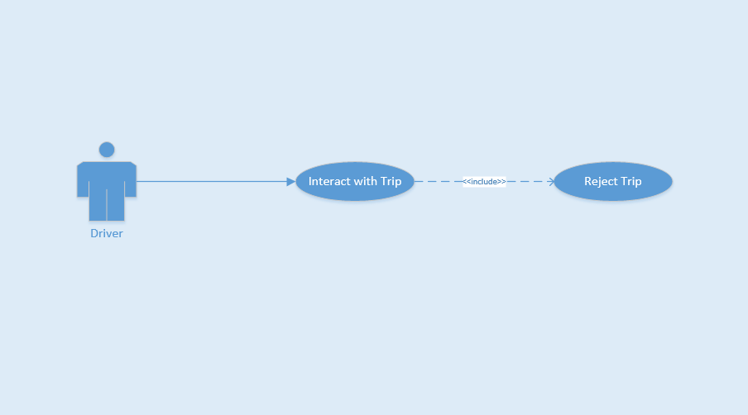

Figure 3‑32 Use-case UC-30

**Table 3‑32** Use-case UC-30 specification

|  |  |  |  |  |
| --- | --- | --- | --- | --- |
| **Use Case ID** | | | UC-30 | |
| **Use Name** | | | Reject Trip | |
| **Actor** | | | Driver | |
| **Description** | | | This function allows Driver rejected request from Rider call | |
| **Precondition** | | | Login | |
| **Trigger** | | | Dialog box show up and Driver tap on “Từ chối” button | |
| **Post-Condition** | | | Driver rejected trip from Rider | |
| **Main flows** | | | | |
| **Step** | **Actor** | | **Action** | |
| 1 | F-Taxi | | Send notification and request from Rider to Driver, show dialog box | |
| 2 | Driver | | Tap on “Từ chối ” button | |
| 3 | F-Taxi | | Driver rejected trip from Rider | |
|  |  | |  | |
| **Alternative flows** | | | | |
|  | |  | | |
| **Step** | | **Actor** | | **Action** |
|  | |  | |  |
|  | |  | |  |

##### UC-31 Start trip

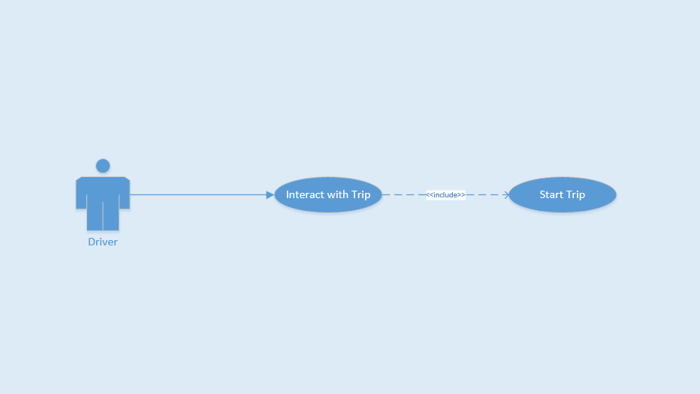

Figure 3‑33 Use-case UC-31

**Table 3‑33** Use-case UC-31 specification

|  |  |  |  |  |
| --- | --- | --- | --- | --- |
| **Use Case ID** | | | UC-31 | |
| **Use Name** | | | Start Trip | |
| **Actor** | | | Driver | |
| **Description** | | | This function allows Driver start a trip after accepted Rider request | |
| **Precondition** | | | Accepted Rider request | |
| **Trigger** | | | Tap on start trip for start calculate fee and distance | |
| **Post-Condition** | | | Started Trip | |
| **Main flows** | | | | |
| **Step** | **Actor** | | **Action** | |
| 1 | F-Taxi | | Show dialog box before Driver picked up Rider | |
| 2 | Driver | | When Rider on taxi, tap on “Bắt đầu” button | |
| 3 | F-Taxi | | Started Trip | |
|  |  | |  | |
| **Alternative flows** | | | | |
|  | |  | | |
| **Step** | | **Actor** | | **Action** |
|  | |  | |  |
|  | |  | |  |

##### UC-32 Cancel trip



Figure 3‑34 Use-case UC-32

**Table 3‑34** Use-case UC-32 specification

|  |  |  |  |  |
| --- | --- | --- | --- | --- |
| **Use Case ID** | | | UC-32 | |
| **Use Name** | | | Cancel Trip | |
| **Actor** | | | Driver | |
| **Description** | | | This function allows Driver cancel a trip after accepted Rider request | |
| **Precondition** | | | Accepted Rider request | |
| **Trigger** | | | Tap on cancel trip when change decision | |
| **Post-Condition** | | | Canceled Trip | |
| **Main flows** | | | | |
| **Step** | **Actor** | | **Action** | |
| 1 | F-Taxi | | Show dialog box before Driver picked up Rider | |
| 2 | Driver | | When Driver change decision, tap on “Hủy” button | |
| 3 | F-Taxi | | Canceled Trip | |
|  |  | |  | |
| **Alternative flows** | | | | |
|  | |  | | |
| **Step** | | **Actor** | | **Action** |
|  | |  | |  |
|  | |  | |  |

##### UC-33 Complete trip

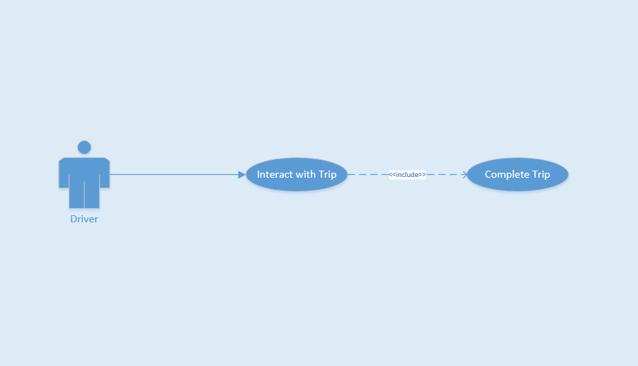

Figure 3‑35 Use-case UC-33

**Table 3‑35** Use-case UC-33 specification

|  |  |  |  |  |
| --- | --- | --- | --- | --- |
| **Use Case ID** | | | UC-33 | |
| **Use Name** | | | Complete Trip | |
| **Actor** | | | Driver | |
| **Description** | | | This function allows Driver view list completed trip | |
| **Precondition** | | | On Home Page screen | |
| **Trigger** | | | Tap on list complete trip button on left menu | |
| **Post-Condition** | | | Show list complete trip successful | |
| **Main flows** | | | | |
| **Step** | **Actor** | | **Action** | |
| 1 | Driver | | On Home Page Screen, them tap on “Lịch sử của tôi” on left menu | |
| 2 | F-Taxi | | Show list complete trip successful | |
| 3 | Driver | | Tap on “Xem chi tiêt” | |
| 4 | F-Taxi | | Show detail trip | |
| **Alternative flows** | | | | |
|  | |  | | |
| **Step** | | **Actor** | | **Action** |
|  | |  | |  |
|  | |  | | |

##### UC-34 View bill detail

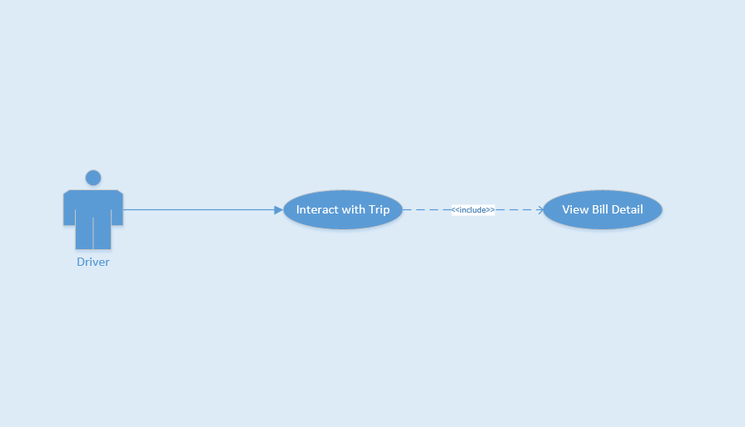

Figure 3‑36 Use-case UC-34

**Table 3‑36** Use-case UC-34 specification

|  |  |  |  |  |
| --- | --- | --- | --- | --- |
| **Use Case ID** | | | UC-34 | |
| **Use Name** | | | View Bill Detail | |
| **Actor** | | | Driver | |
| **Description** | | | This function allows Driver view bill detail of trip | |
| **Precondition** | | | Finished Trip | |
| **Trigger** | | | Tap on “Chạm để thanh toán” button | |
| **Post-Condition** | | | Show bill detail successful | |
| **Main flows** | | | | |
| **Step** | **Actor** | | **Action** | |
| 1 | Driver | | Tap on “Chạm để thanh toán” button | |
| 2 | F-Taxi | | Show bill detail on screen Driver | |
| 3 | Driver | | Tap on “Thanh toán” button and receive payment from Rider | |
| 4 | F-Taxi | | Show bill detail on screen Rider | |
| **Alternative flows** | | | | |
|  | |  | | |
| **Step** | | **Actor** | | **Action** |
|  | |  | |  |
|  | |  | |  |

### Non-Functional Requirements

#### Usability

* User can easy take a trip in few tap on screen.
* Support Vietnamese for user can easy understand.

#### Reliability

* Passwords must be encoded in database as MD5 type.
* The database must be backed up daily and can be recovered if necessary.

#### Performance

* Time for loading content is 3-5 seconds depend on speed of internet.
* Time to process ant function will not exceed 7 seconds.

#### Supportability

* Coding standards, naming conventions and class library are noted to support later changes.
* Support log and fix bug.

# Software Design Description

## SDD Overview

* This document provides the software design description of the Taxi Caller application. It relies on requirements in section 3 and includes all of important information that describes how the system does.
* This section of document is the **software design description** of the project in order to develop the software, it includes three main parts: Architecture Design, Class Design and Detail Design.

## Architecture Design

### System Overall

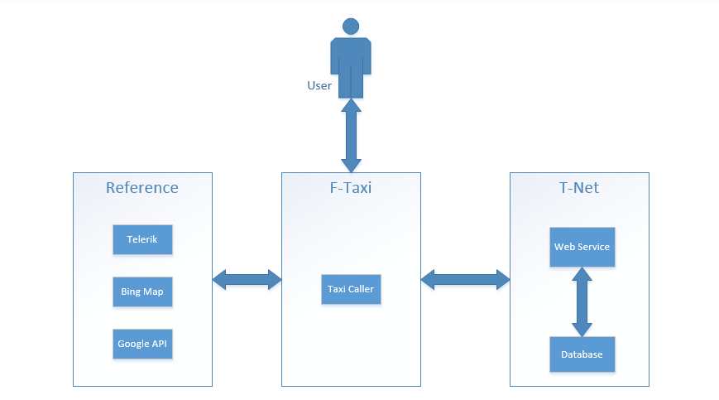

Figure 4‑1 System Overall

### Software Architect

#### Layered Architecture



Figure 4‑2 Layered architecture for F-Taxi application

##### Layered Architecture Style

Layered software architecture is a hierarchical architecture that uses many layers for allocating the different responsibilities of a software product.

The system is decomposed into a number of higher and lower layers in a hierarchy; each layer consists of a group of related classes that are encapsulated in a package, in a deployed component, or as a group of subroutines in the format of method library or header file. Also, each layer has its own responsibility in the system.

Each layer has its own responsibility as follow:

###### Presentation Layer

* Presentation Layer: provides user interface, handles the interaction with the user.
* Presentation Layer: is responsible for the delivery and formatting of information to the application layer for further processing or display.
* Presentation Layer: will receive input data from users and response the result again users.
* In F-Taxi application: using Telerik Controls to design some user interface. Bing map to display Maps and navigation with two main user. Google API. Notification to communicate with two kind of user Rider and Driver.

###### Business Operation Layer

* Business Layer: will set of rules for processing information, can accommodate many users.
* Business Layer: coordinates the application, process commands, makes logical decisions and evaluations and performs calculations, it also moves and processes data between the two surrounding layers.
* In F-Taxi application: using classes and object to work with T-Net which is a company that supply web service and communicate with database.

###### Data access layer

* Business Layer: will set of rules for processing information, can accommodate many users.
* Business Layer: coordinates the application, process commands, makes logical decisions and evaluations and performs calculations, it also moves and processes data between the two surrounding layers.
* In F-Taxi application: using classes and object to work with T-Net, T-Net is a company supply web service and communicate with database.

##### Advantages of Layered Architecture

* Incremental software development base on increasing levels of abstraction.
* Enhanced independence of upper layer to lower layer since there is no impact from the changes of lower layer services as long as their interfaces remain unchanged.
* Enhanced flexibility: interchange ability and reusability are enhanced due to the separation of the standard interface and its implementation.
* Component-based technology is a suitable technology to implement layered architecture; this makes it much easier for the system to allow for plug-and-play of new components. Components are reusable, easier to maintain and fast development. Web designer does presentation, Software engineer does logic and Database admin does data model.
* Promotion of portability: each layer can be an abstract machine deployed independently.

## Detail Design

### Class Design

#### Rider

##### Login

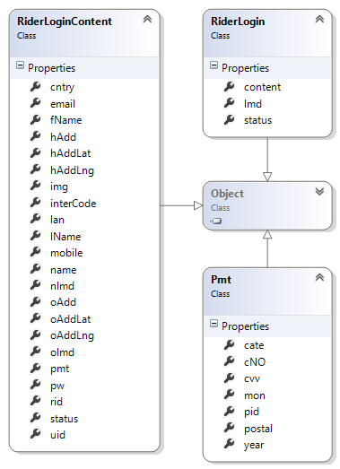

##### Get List Favorite Driver

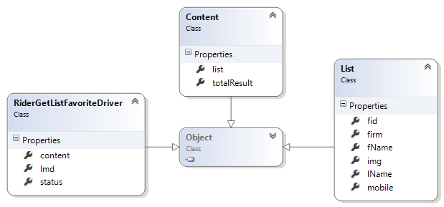

##### Get List City

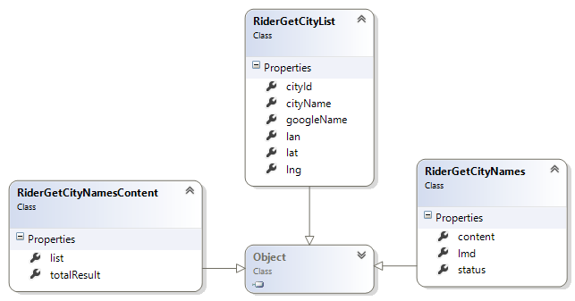

##### Get My Trip

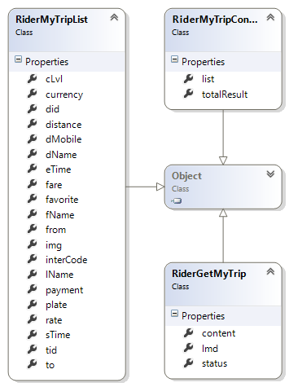

##### Get Near Driver

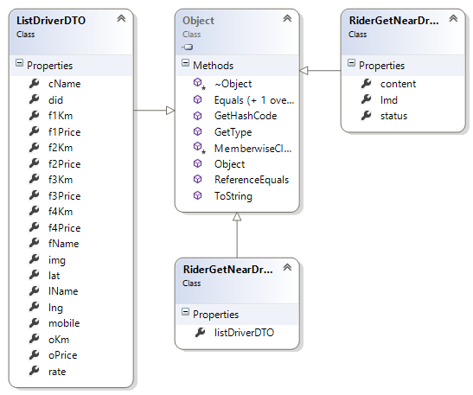

#### Driver

##### Login

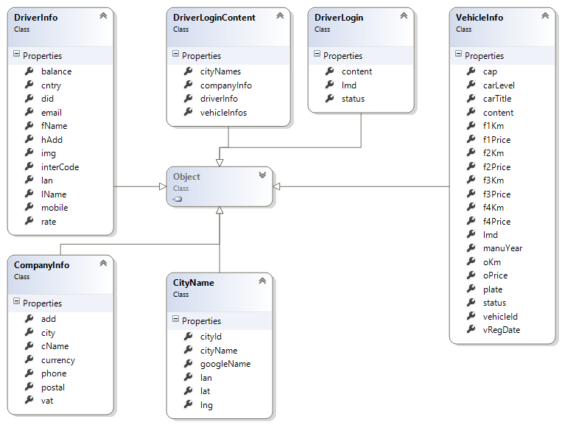

##### Accept Trip

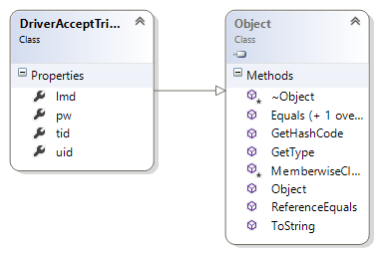

##### Complete Trip

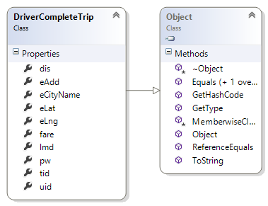

##### Notify New Trip

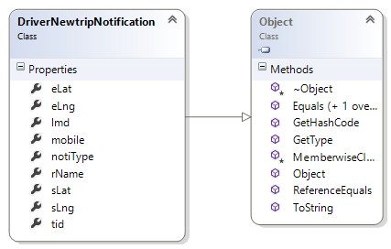

##### Notify Update Trip

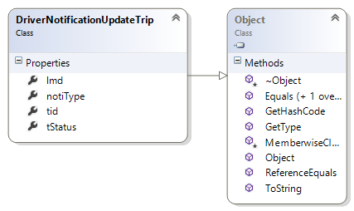

##### Select Available Vehicle

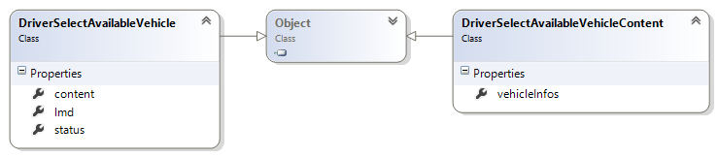

### Sequence diagram

#### Register sequence diagram

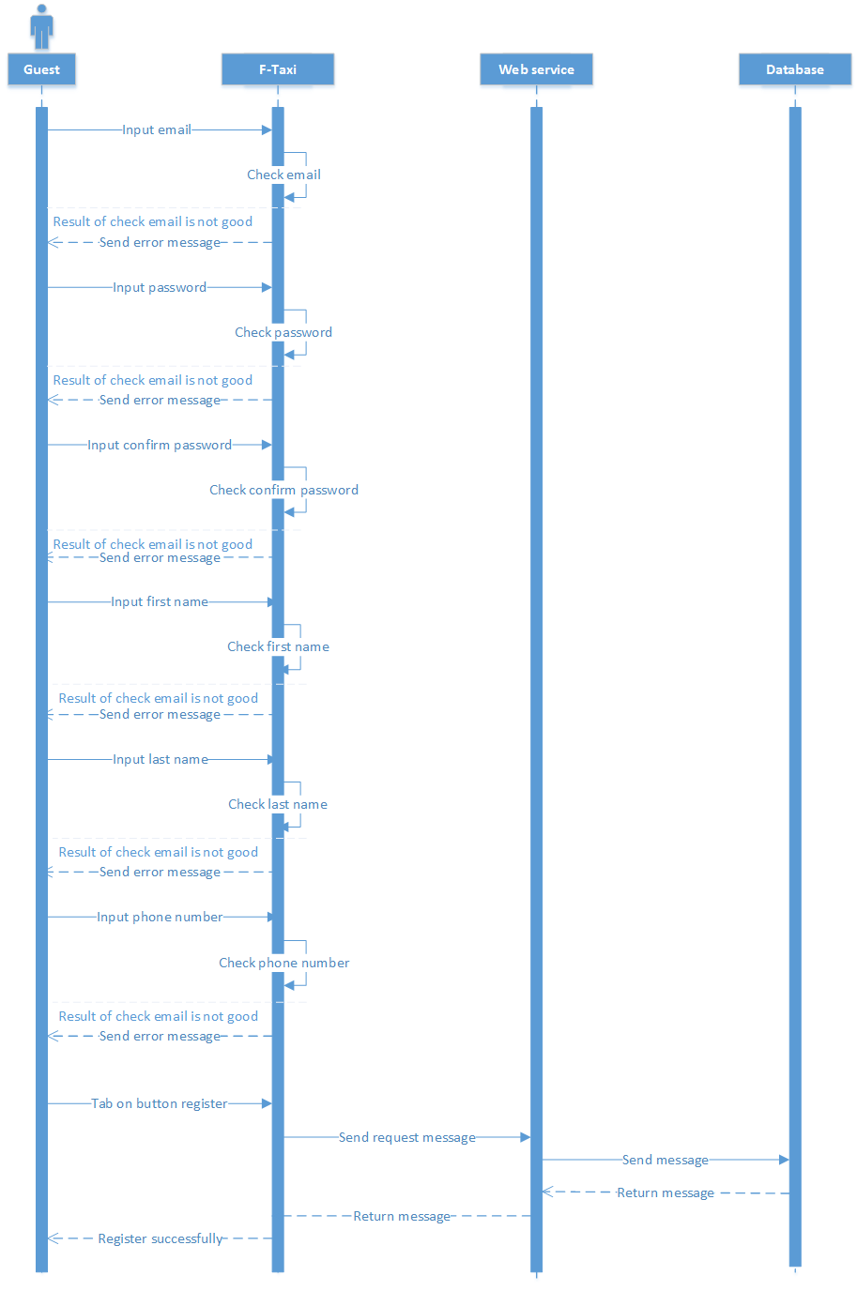

#### Login sequence diagram

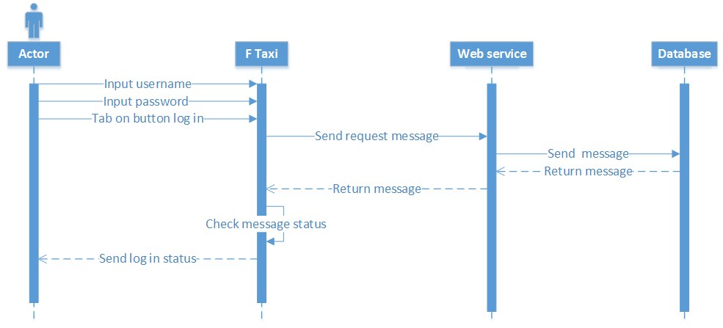

#### Create Trip sequence diagram

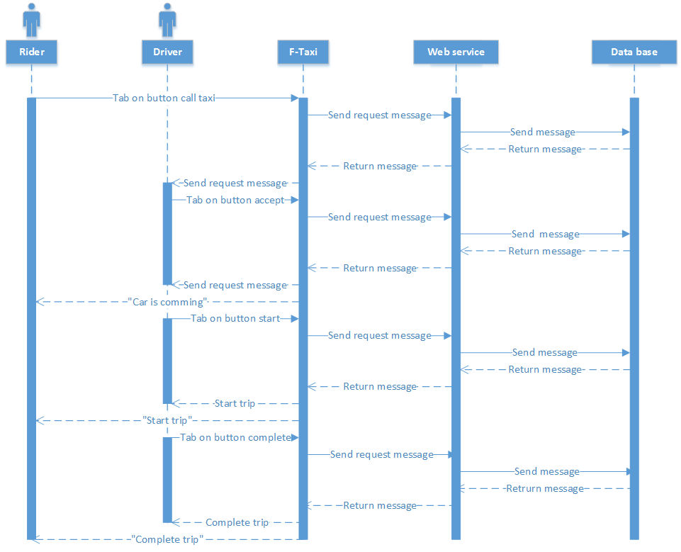

### Screen Design

#### Guest

##### First Page



|  |  |  |
| --- | --- | --- |
| Element | Type | Description |
| Bỏ qua để bắt đầu | Button | Show Login Page |
| Hướng dẫn sử dụng F-Taxi | Image | Show Introduction of application |

##### Register



|  |  |  |
| --- | --- | --- |
| Element | Type | Description |
| Email text field | Edit text | Enter Email |
| Mật khẩu text field | Edit text | Enter Password |
| Nhập lại mật khẩu text field | Edit text | Enter Confirm Password |
| Tên text field | Edit text | Enter Last Name |
| Họ text field | Edit text | Enter First and Middle Name |
| Số điện thoại text file | Edit text | Enter Phone Number |
| Đăng ký | Button | Register new user as Rider |

#### Rider

##### Login



|  |  |  |
| --- | --- | --- |
| Element | Type | Description |
| Tài khoản text field | Edit text | Enter Email |
| Mật khẩu text field | Edit text | Enter Password |
| Đăng nhập | Button | Tap button for logging in application |
| Quên mật khẩu | Label | Tap label for showing forget password screen |

##### Forget password



|  |  |  |
| --- | --- | --- |
| Element | Type | Description |
| Email text field | Edit text | Enter Email |
| Đặt lại mật khẩu | Button | Tap button for send password to email user |

##### Home Page

###### Home Page



|  |  |  |
| --- | --- | --- |
| Element | Type | Description |
| Map | Map | Show map |
| Taxi Image | Button | Clickable button for show Trip bar |
| Chọn điểm đón | Button | Clickable button for choose pick up position |
| Menu | Menu | Show left menu |
| Địa chỉ đón text field | Edit Text | Text field to enter keyword to search |
| Marker | Image | Always on middle of screen for user choose pick up position |
| My position | Image | Show current user position |
| Taxi icon | Button | Clickable button for show kind of taxi |

###### Home Page with trip bar

 

|  |  |  |
| --- | --- | --- |
| Element | Type | Description |
| Map | Map | Show map |
| Taxi Image | Button | Clickable button for show Trip bar |
| Menu | Menu | Show left menu |
| My position | Image | Show current user position |
| Địa chỉ đón text field | Edit Text | Text field to enter keyword to search |
| Giá mở cửa | Text | Show open price |
| Phí ước tích | Text | Show estimate payment price |
| Điểm đón | Text | Show pick up position |
| Điểm đến text field | Text edit | Text field to enter keyword to search |
| Ảnh (tên lái xe) | Image | Show driver information |
| Mã khuyến mại | Text edit | Enter field for discount trip |
| Tự động gọi xe khác khi bận | Checkbox | Tick on for automatic call other taxi |
| Yêu cầu taxi | Button | Tap button for call taxi |
| Vui lòng đợi (chạm để hủy) | Button | Tap button for cancel call taxi |
| Xe đang đến (chạm để hủy) | Button | Tap button for cancel call taxi |

###### Home Page when no taxi around



|  |  |  |
| --- | --- | --- |
| Element | Type | Description |
| Map | Map | Show map |
| Gọi | Button | Tap button for calling taxi centre |
| Menu | Menu | Show left menu |
| My position | Image | Show current user position |
| Taxi icon | Button | Tap button for show kind of taxi |

##### Bill Detail



|  |  |  |
| --- | --- | --- |
| Element | Type | Description |
| Tên | Text | Show name driver |
| Lần đầu tiên | Text | Show number trip user take |
| Ảnh | Image | Show avatar of driver |
| Điểm đón | Text | Show start position |
| Điểm đích | Text | Show destination position |
| Quãng đường | Text | Show total trip |
| Tổng phí | Text | Show total price |
| Khuyến mại | Text | Show price discount |
| Thanh toán | Text | Show payment price |
| Hình thức thanh toán | Text | Show form of payment |
| Đánh giá | Image | Show 1-5 star for user rate |
| Đóng | Button | Tap on for close detail bill |

##### Left menu



|  |  |  |
| --- | --- | --- |
| Element | Type | Description |
| Ảnh | Image | Show image avatar of user |
| Tên | Text | Show name of user |
| Họ và tên đệm | Text | Show first and middle name of user |
| Hồ sơ cá nhân | Text block | Tap on for show profile page |
| Lịch sử chuyến đi | Text block | Tap on for show history trip page |
| Tài xế yêu thích | Text block | Tap on for show favorite driver page |
| Về chúng tôi | Text block | Tap on for show about page |
| Phản hồi | Text block | Tap on for show send feedback page |
| Đăng xuất | Button | Tap on for logout application |

###### Profile



|  |  |  |
| --- | --- | --- |
| Element | Type | Description |
| Sửa1 | Button | Tap on for edit profile |
| Lưu | Button | Tap on for save edit profile |
| Ảnh | Image | Show image avatar of user |
| Tên | Text | Show name of user |
| Họ và tên đệm | Text | Show first and middle name of user |
| Mail | Textbox | Show email |
| Số điện thoại | Textbox | Show phone number |
| Ngôn ngữ | Textbox | Show language |
| Địa chỉ nhà | Textbox | Show home address |
| Địa chỉ công ty | Textbox | Show company address |
| Sửa2 | Button | Tap on for show home address page |
| Sửa3 | Button | Tap on for show company address page |
| Đổi mật khâu | Text block | Tap on for show change password page |

###### History Trip



|  |  |  |
| --- | --- | --- |
| Element | Type | Description |
| Tên | Text | Show name driver |
| Biển số xe | Text | Show car number |
| Ảnh | Image | Show avatar of driver |
| Điểm đi | Text | Show start position |
| Điểm đến | Text | Show destination position |
| Thời gian | Text | Show time of trip |

###### Favorite Driver



|  |  |  |
| --- | --- | --- |
| Element | Type | Description |
| Tên | Text | Show name driver |
| Số điện thoại | Text | Show phone number |
| Ảnh | Image | Show avatar of driver |

###### Send Application feedback



|  |  |  |
| --- | --- | --- |
| Element | Type | Description |
| Tiêu đề | Text edit | Enter title message |
| Nội dung | Text edit | Enter content message |
| Gửi phản hồi | Button | Tap on for send feedback message |

###### About Us



|  |  |  |
| --- | --- | --- |
| Element | Type | Description |
| F-Taxi | Text | Description application |

#### Driver

##### Login



|  |  |  |
| --- | --- | --- |
| Element | Type | Description |
| Tài khoản text field | Edit text | Enter Email |
| Mật khẩu text field | Edit text | Enter Password |
| Đăng nhập | Button | Tap button for logging in application |
| Quên mật khẩu | Label | Tap label for showing forget password screen |

##### Forget Password



|  |  |  |
| --- | --- | --- |
| Element | Type | Description |
| Email text field | Edit text | Enter Email |
| Đặt lại mật khẩu | Button | Tap button for send password to email user |

##### Home Page

###### Home Page



|  |  |  |
| --- | --- | --- |
| Element | Type | Description |
| Menu | Menu | Show left menu |
| My position | Image | Show current user position |
| Map | Map | Show Map |
| Chuyển qua chế độ nghỉ | Button | Tap on for change driver status |

###### Home Page with trip



|  |  |  |
| --- | --- | --- |
| Element | Type | Description |
| Menu | Menu | Show left menu |
| My position | Image | Show current user position |
| Map | Map | Show Map |
| Ảnh | Image | Show avatar Rider |
| Hành khách | Text | Show name Rider |
| Số điện thoại | Text | Show phone number Rider |
| Địa chỉ | Text | Show address Rider |
| Chấp nhận | Button | Tap on for accept trip |
| Từ chối | Button | Tap on for reject trip |

##### Bill Detail



|  |  |  |
| --- | --- | --- |
| Element | Type | Description |
| Tên | Text | Show name driver |
| Lần đầu tiên | Text | Show number trip user take |
| Ảnh | Image | Show avatar of driver |
| Điểm đón | Text | Show start position |
| Điểm đích | Text | Show destination position |
| Quãng đường | Text | Show total trip |
| Tổng phí | Text | Show total price |
| Khuyến mại | Text | Show price discount |
| Thanh toán | Text | Show payment price |
| Hình thức thanh toán | Text | Show form of payment |
| Thanh toán | Button | Tap on for close detail bill |

##### Left Menu



|  |  |  |
| --- | --- | --- |
| Element | Type | Description |
| Ảnh | Image | Show image avatar of user |
| Tên | Text | Show name of user |
| Họ và tên đệm | Text | Show first and middle name of user |
| Hồ sơ cá nhân | Text block | Tap on for show profile page |
| Lịch sử chuyến đi | Text block | Tap on for show history trip page |
| Thông tin công ty | Text block | Tap on for show company information |
| Về chúng tôi | Text block | Tap on for show about page |
| Phản hồi | Text block | Tap on for show send feedback page |
| Đăng xuất | Button | Tap on for logout application |

###### Profile



|  |  |  |
| --- | --- | --- |
| Element | Type | Description |
| Ảnh | Image | Show image avatar of user |
| Tên | Text | Show name of user |
| Họ và tên đệm | Text | Show first and middle name of user |
| Mail | Textbox | Show email |
| Số điện thoại | Textbox | Show phone number |
| Ngôn ngữ | Textbox | Show language |
| Tiền | Textbox | Show balance money |
| Địa chỉ nhà | Textbox | Show home address |
| Sửa | Button | Tap on for show home address page |
| Đổi mật khâu | Text block | Tap on for show change password page |

###### History Trip



|  |  |  |
| --- | --- | --- |
| Element | Type | Description |
| Tên | Text | Show name driver |
| Biển số xe | Text | Show car number |
| Ảnh | Image | Show avatar of driver |
| Điểm đi | Text | Show start position |
| Điểm đến | Text | Show destination position |
| Thời gian | Text | Show time of trip |

###### Company Information



|  |  |  |
| --- | --- | --- |
| Element | Type | Description |
| Logo | Image | Show logo company |
| Địa chỉ | Text | Show company address |
| Mã bưu điện | Text | Show postal code |
| Số điện thoại | Text | Show phone number |
| Mã số VAT | Text | Show VAT code |
| Loại xe | Text | Show type of taxi |
| Sản xuất | Text | Show manufacture year |
| Biển số | Text | Show car number |
| Đăng kiểm | Text | Show time registry |
| Quay lại | Button | Tap on for back to Home Page screen |

###### Send application feedback



|  |  |  |
| --- | --- | --- |
| Element | Type | Description |
| Tiêu đề | Text edit | Enter title message |
| Nội dung | Text edit | Enter content message |
| Gửi phản hồi | Button | Tap on for send feedback message |

###### About Us



|  |  |  |
| --- | --- | --- |
| Element | Type | Description |
| F-Taxi | Text | Description application |

# Software Test Documentation

## Test Overview

### Test Approach

We use V-model to implement testing process.

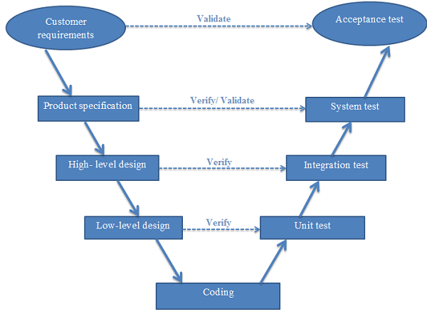

Figure 6‑1 V-model

Due to requirement of project must be always suitable with user, we choose V-model to implement testing process. With V-Model, software development is separated into two appropriate phase’s groups: development and testing. In this model, the verification and validation will be done side by side. It emphasizes the strict process flow to develop a quality product. The errors occurred in any phase will be corrected in that phase. Proactive defect tracking defects which are found at early stages even may be in the development phase before application being tested (Unit test).

Testing progress is divided to 4 phases include: Unit test, Integration test, System test and Acceptance test.

#### Unit testing

* The purpose is to verify the internal logic code by testing every possible branch within the function, also known as test coverage.
* Unit test will be done by the developers and will be approved by the implementing team leader to ensure that the building blocks of the system uses work independently of each other and the specific function is working as expected. One function might have multiple tests to catch corner cases in the code

#### Integration testing

* The separate modules will be tested together to expose faults in the interfaces and in the interaction between integrated components.
* Integration testing will be done by tester.

#### System testing

* Compare the system specifications against the actual system.
* System testing checks if the integrated product meets the specified requirements.

#### Acceptance testing

* Acceptance testing will be performed by the test manager and development team leader.
* The acceptance test will be done for a period of 1 week after completion of the System/Integration test process.
* Programs will enter into Acceptance test after all critical and major defects have been corrected.
* Prior to final completion of acceptance testing all open critical and major defects must be corrected.

### Test Strategy

#### Functional Test

Functional testing bases its test cases on the specifications of the component under test. Functions are tested by feeding them input and examining the output.  
Functional testing typically involves four steps:

* The creation of input data based on the function's specifications
* The determination of output based on the function's specification
* The execution of the test case
* The comparison of actual and expected outputs

#### User Interface Test

During testing, focus is shifted towards application specific aspects of user interaction as they are manifested by interface syntax and semantics. The goal of interface testing is to:

* Uncover errors related to specific interface mechanism.
* Uncover errors in the way interface implements semantics of navigation, web application functionality or content display.

Objectives that should be achieved are:

* Interface features are tested to ensure that design rules, aesthetics, and related visual content are available for user without error.
* Individual interface mechanisms are tested in a manner that is analogous to unit testing.
* Each interface mechanism is tested within the context of a use case or navigation semantic units for a specific user category.
* The complete interface is tested against selected use cases and navigation semantic units to uncover errors in the semantics of the interface.

## Test Plan

### Feature to be tested

Developers will be performed unit test to ensure that all functions are working as expected.

The test team will be undertaking the responsibility of testing and validating the operation of the part that developed. The functions developed require completing design and execution of function tests to ensure proper coverage.

Following are items that will need to be tested by testers:

**Table 5‑1** Feature to be tested

|  |  |  |  |  |  |
| --- | --- | --- | --- | --- | --- |
| No. | Component | | Feature Name | | Feature to be tested |
|  | Interface | Rider screen | Screen elements | | Check the display of elements. |
| Driver screen |
|  | Function | Main application |  | Login | Login |
|  |  | Logout | Logout |
|  | Account management |  | Register account |
|  | View profile |
|  | Update profile |
|  | Change password |
|  | Forget password |
|  | Rider actions | Work with trips | Create trip |
|  | Cancel trip |
|  | View completed trips |
|  | View bill detail |
|  | Rate driver |
|  | Favorites management | View favorite driver |
|  | Add favorite driver |
|  | Delete favorite driver |
|  | Call favorite driver |
|  | Find lost assets | Find lost assets |
|  | Send Application Feedback | Send Application Feedback |
|  | Call Taxi Center | Call Taxi Center |
|  | Driver actions | Work with trips | Accept trip |
|  | Reject trip |
|  | Cancel trip |
|  | Complete trip |
|  | Start trip |
|  | View bill detail |
|  | Notify lost assets | Notify lost assets |
|  | Change status | Change status |
|  | Conflict |  | Conflict | | |

### Feature not to be tested

* Maintainability.
* Security testing

### Create test case plan

**Table 5‑2** Create test cases plan

|  |  |  |  |  |  |  |  |
| --- | --- | --- | --- | --- | --- | --- | --- |
| Date | December | | | | | | Total |
| 27 | 27 | 27 | 27 | 27 | 27 |
| Create TC | 43 | 25 | 13 |  |  | 10 |  |
| HuuPG | GUI | Account | Log in-Log out | Rider actions | Driver action | Conflict |  |

### Execute test plan

**Table 5‑3** Execute test plan

|  |  |  |  |  |  |  |  |
| --- | --- | --- | --- | --- | --- | --- | --- |
| Date | Round 1 | | | | | | Total |
| December | | | | | |
| 11 | | | 12 | | |
| Execute Test (TC) |  |  |  |  |  |  |  |
| LapNV |  | x |  | x |  | x |  |
| HuuPG | x |  | x |  | x |  |  |
| Bug |  |  |  |  |  |  |  |
| Method | GUI | Log in-Log out | Account | Driver action | Rider actions | Conflict |  |

|  |  |  |  |  |  |  |  |  |  |
| --- | --- | --- | --- | --- | --- | --- | --- | --- | --- |
| Date | Round 2 | | | | | | | | Total |
| December | | | | | | | |
| 13 | | | | 14 | | | |
| Execute Test (TC) |  |  |  |  |  |  |  |  |  |
| LapNV |  |  |  |  |  |  |  |  |  |
| HuuPG |  |  |  |  |  |  |  |  |  |
| Bug |  |  |  |  |  |  |  |  |  |
| Method | All | | | | | | | |  |

### Testing Environments

#### Software

**Table 5‑4** Software needed for testing

|  |  |  |
| --- | --- | --- |
| Category | Software name | Version |
| Operating System | Windows Phone |  |
| Development framework | Microsoft .NET | 4.0 |
| Development tools | Microsoft Visual Studio | 2013 |
| Notepad++ | Newest |
| Data managing tools | TortoiseGIT | Newest |
| Support tools | Chrome, Internet Explorer, Photoshop | Newest |
| Assign task and tracking bug | Microsoft Excel | Newest |
| Testing tools | - | - |

#### Hardware

At server: T-NET

Smart phone 1: LUMINA 630

* OS: Windows phone 8.1
* Install memory (RAM) : 1.00GB

Smart phone 2: LUMINA 720

* OS: Windows phone 8.1
* Install memory (RAM) : 1.00GB

### Resource

Developer, tester and project manager has to join in testing process.

**Table 5‑5** Resource and Responsibility in Test process

|  |  |
| --- | --- |
| Resource | Responsibility |
| Developers | Unit test, fix all bugs after testing |
| Tester | Create test cases, test plan, test report, bug list report |
| Prepare data to test |
| Log bugs |
| Test and retest to limit maximize bugs |
| Project manager | Responsible for project schedules |

### Test Milestones

**Table 5‑6** Test milestones

|  |  |  |  |
| --- | --- | --- | --- |
| Milestone Task | Resource | Start Date | Finish date |
| Create Test plan | Test leader | 2015/11/27 | 2015/11/27 |
| Create Unit Test cases | Developer | 2015/11/28 | 2015/11/29 |
| Create Integration Test cases | Tester | 2015/11/28 | 2015/11/29 |
| Create System Test cases | Tester | 2015/11/30 | 2015/12/01 |
| Review Unit Test cases | Project Team | 2015/11/30 | 2015/11/30 |
| Review Integration Test cases | Project Team | 2015/12/01 | 2015/12/01 |
| Review System Test cases | Project Team | 2015/12/02 | 2015/12/02 |
| Update Test cases | Tester | 2015/12/03 | 2015/12/03 |
| Create data test | Tester | 2015/12/03 | 2015/12/03 |
| Execute Unit Test | Developer |  |  |
| Execute Integration Test | Tester |  |  |
| Execute System Test | Tester |  |  |

## Test Cases

### Login

**Table 5‑7** Login test cases

|  |  |  |  |  |  |  |  |  |
| --- | --- | --- | --- | --- | --- | --- | --- | --- |
| Module Code | Login | | | | | |  |  |
| Test requirement |  | | | | | |  |  |
| Tester | HuuPG | | | | | |  |  |
| ID | **Test Case Description** | **Test Case Procedure** | **Expected Output** | **Inter-test case Dependence** | **Result1** | **Result2** | **Test date** | **Note** |
|  | **Login as Rider** | | | | | | | |
| [Login-1] | Login successfully | 1. Input valid email and password  2. Tap on button "Đăng nhập" | 2. Move to Rider Homepage screen |  | Fail | Pass |  |  |
| [Login-2] | Check format of email | 1. Input invalid format of email  2. Tap on button "Đăng Nhập" | 2. Show error message "Email không hợp lệ" |  | Fail | Pass |  |  |
| [Login-3] | Check email is blank | 1. Let email is blank  2. Input password  3. Tap on button "Đăng Nhập" | 3. Show error message "Mời bạn nhập email" |  | Fail | Pass |  |  |
| [Login-4] | Check password is blank | 1. Input valid email  2. Let password is blank  3. Tap on button "Đăng Nhập" | 3. Show error message "Mời bạn nhập password" |  | Pass | Pass |  |  |
| [Login-5] | Check email is invalid | 1. Input invalid email  2. Input valid password  3. Tap on button "Đăng Nhập" | 3. Show error message "Tài khoản không đúng" |  | Fail | Pass |  |  |
| [Login-6] | Check password is invalid | 1. Input valid email  2. Input invalid password  3. Tap on button "Đăng Nhập" | 3. Show error message "Mật khẩu không đúng" |  | Pass | Pass |  |  |

### Register

**Table 5‑8** Register test cases

|  |  |  |  |  |  |  |  |  |
| --- | --- | --- | --- | --- | --- | --- | --- | --- |
| Module Code | Register | | | | | |  |  |
| Test requirement |  | | | | | |  |  |
| Tester | HuuPG | | | | | |  |  |
| ID | **Test Case Description** | **Test Case Procedure** | **Expected Output** | **Inter-test case Dependence** | **Result1** | **Result2** | **Test date** | **Note** |
|  | **Register** | | | | | | | |
| [Account-1] | Register successfully | 1. Input valid data in all field.  2. Tap on "Đăng ký" button | 2. Move to Log in screen |  | Pass | Pass |  |  |
| [Account-2] | Check email is blank | 1. Let email is blank | 1. Show error message "Vui lòng nhập email" Name, Profile picture, Address f, Report breach area  Reason textbox, “Report breach” button |  | Fail | Pass |  |  |
| [Account-3] | Check password is blank | 1. Let password is blank | 1. Show error message "Vui lòng nhập mật khẩu" |  | Fail | Pass |  |  |
| [Account-4] | Check confirm password is blank | 1. Let confirm password is blank | 1. Show error message "Vui lòng nhập mật khẩu" |  | Fail | Pass |  |  |
| [Account-5] | Check first name is blank | 1. Let first name is blank | 1. Show error message "Vui lòng nhập tên của bạn" |  | Pass | Pass |  |  |
| [Account-6] | Check last name is blank | 1. Let last name is blank | 1. Show error message "Vui lòng nhập ho của bạn" |  | Pass | Pass |  |  |
| [Account-7] | Check phone number is blank | 1. Let phone is blank | 1. Show error message "Vui lòng nhập số điện thoại" |  | Pass | Pass |  |  |
| [Account-8] | Check email is space | 1. Let email is space | 1. Show error message "Vui lòng nhập email" |  | Pass | Pass |  |  |
| [Account-9] | Check phone number is space | 1. Let phone number is space | 1. Show error message "Vui lòng nhập số điện thoại" |  | Fail | Pass |  |  |
| [Account-10] | Check last name is space | 1. Let last name is space | 1. Show error message "Vui lòng nhập ho của bạn" |  | Fail | Pass |  |  |
| [Account-11] | Check first name is space | 1. Let first name is space | 1. Show error message "Vui lòng nhập tên của bạn" |  | Pass | Pass |  |  |
| [Account-12] | Check duplication | 1. Input input email which is similarly to existed account  2. Tap on “Đăng ký” button | 2. Show error message "Tài khoản đã tồn tại". |  | Fail | Pass |  |  |
| [Account-13] | Check email format | 1. Guest input invalid email format (eg: x@y.z)  2. Tap on "Đăng ký" button | 1. Show error message "Nhập lại email". |  | Pass | Pass |  |  |
| [Account-14] | Check max length of mail | 1. Let email have more than 50 characters | 1. Show error message "Email lớn nhất 50 kí tự". |  | Pass | Pass |  |  |
| [Account-15] | Check min length of mail | 1. Let email have less than 15 characters | 1. Show error message "Email nhỏ nhất 15 kí tự". |  | Fail | Pass |  |  |
| [Account-16] | Check max length of password | 1. Let password have more than 24 characters | 1. Show error message "Mật khẩu lớn nhất 24 kí tự". |  | Fail | Pass |  |  |
| [Account-17] | Check min length of password | 1. Let password have less than 6 characters | 1. Show error message "Mật khẩu nhỏ nhất 6 kí tự". |  | Fail | Pass |  |  |
| [Account-18] | Check max length of confirm password | 1. Let confirm password have more than 24 characters | 1. Show error message "Mật khẩu lớn nhất 24 kí tự". |  | Fail | Pass |  |  |
| [Account-19] | Check min length of confirm password | 1. Let confirm password have less than 6 characters | 1. Show error message "Mật khẩu nhỏ nhất 6 kí tự". |  | Pass | Pass |  |  |

### Conflict

**Table 5‑9** Conflict

|  |  |  |  |  |  |  |  |  |
| --- | --- | --- | --- | --- | --- | --- | --- | --- |
| Module Code | Conflict | | | | | |  |  |
| Test requirement |  | | | | | |  |  |
| Tester | HuuPG | | | | | |  |  |
| ID | **Test Case Description** | **Test Case Procedure** | **Expected Output** | **Inter-test case Dependence** | **Result1** | **Result2** | **Test date** | **Note** |
|  | **Conflict** | | | | | | | |
| [Conflict-1] | While using application, calling came | Accept call then finish call | Revert to latest status of application before calling |  | Fail | Pass |  |  |
| [Conflict -2] | Reject call | Revert to latest status of application before calling |  | Fail | Pass |  |  |
| [Conflict -3] | While using application, message came | View message and close | Revert to latest status of application before calling |  | Fail | Pass |  |  |
| [Conflict -4] | Close message | Revert to latest status of application before calling |  | Pass | Pass |  |  |
| [Conflict -5] | While using application, alarm came  Check password is invalid | Close alarm | Revert to latest status of application before calling |  | Fail | Pass |  |  |
| [Conflict -6] | Let alarm run until finish | Revert to latest status of application before calling |  | Pass | Pass |  |  |

## Test Report

**Table 5‑10** Test report



# Software User Manual

## INSTALLATION GUIDE

### Purposes

This user’s manual has been developed to help users better understand the requirements that may apply to use this windows phone application by providing them simple step-by-step tutorials. This manual is intended to help making application functions more accessible and their associated requirements more understandable to users.

### Environments

* Visual Studio 2013:
  + Download on <https://www.visualstudio.com/downloads/download-visual-studio-vs> .
  + Install.
* Smart Phone with Windows Phone OS

## USER's GUIDE

### Guest

#### First page

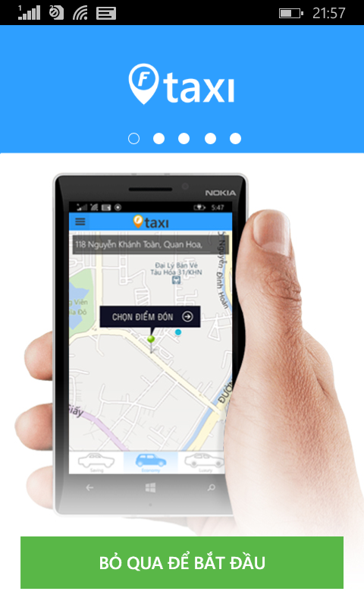

* Slide image on screen or tap on “Bỏ qua để bắt đầu” for move to Login page

#### Create an account

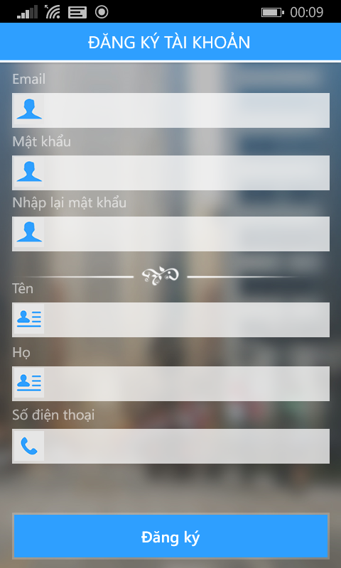

* Step 1 : Tap on “Đăng ký” button on screen
* Step 2 : Fill all information with right format.
* Step 3 : Tap on “Đăng ký” button for register. After that, your account will be ready to using F-Taxi.

### Rider

#### Login to application

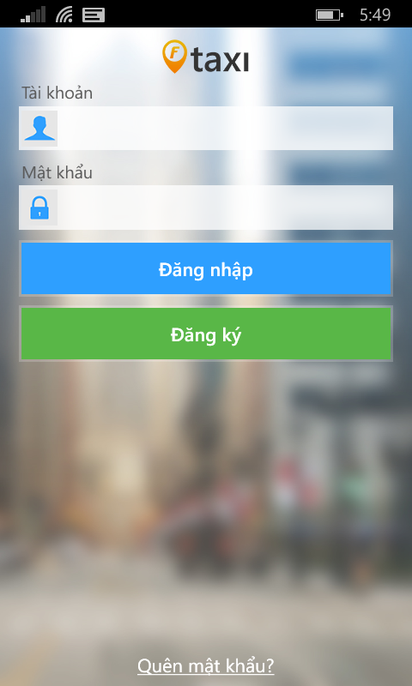

* Step 1: Fill your account on field.
* Step 2: Tap on “Đăng nhập” button.

#### Take a taxi

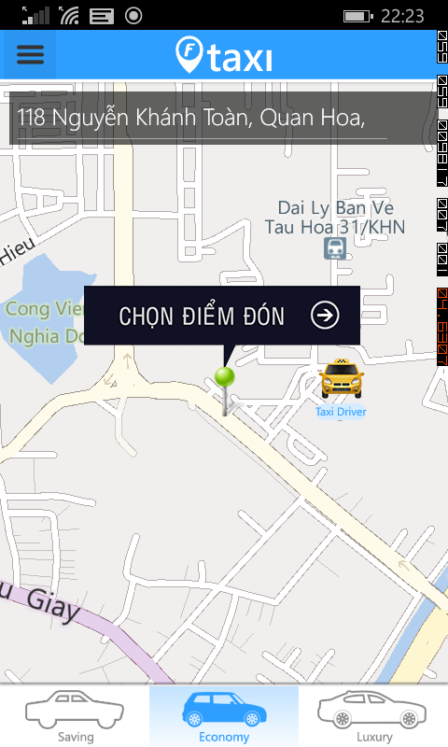

* Step 1: Using your finger to choose types of vehicle. There are up to three types of vehicle services for F-Taxi are: Saving, Economy, Luxury.
* Step 2: Mark your position on the map with a pin. This pin represents where the driver will be expecting to pick you up. You can also manually type in the pickup location on search bar. Once your location is set, tap on “Chọn điểm đón” button.

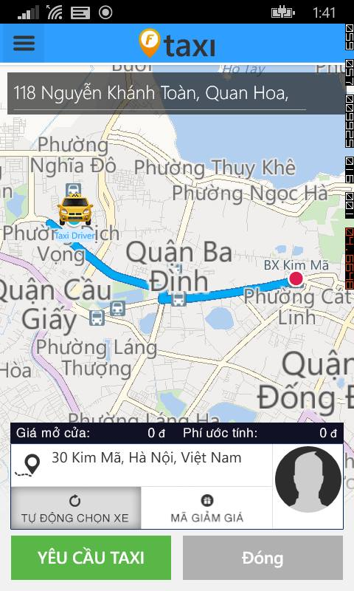

* Step 3: After tap on “Chọn điểm đón” button, show trip bar information. After, you can fill destination on line trip bar. If you have promotion code, tap on “Mã giảm giá”, F-Taxi will show the screen for you enter promotion code. Then, Tap on “Yêu cầu Taxi” button. (Tap on “Đóng” for new pick up address )

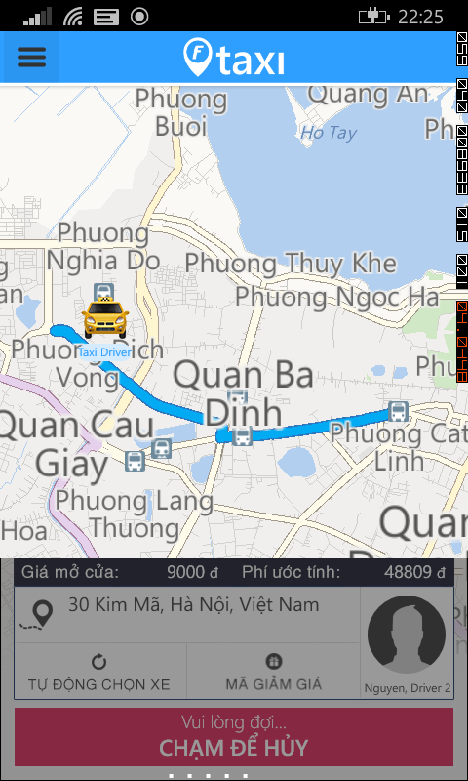

* Step 4: After tap on “Yêu cầu Taxi” button. Waiting Driver accept your request. You can tap on “Chạm để hủy” for cancel this request if you change your decision.

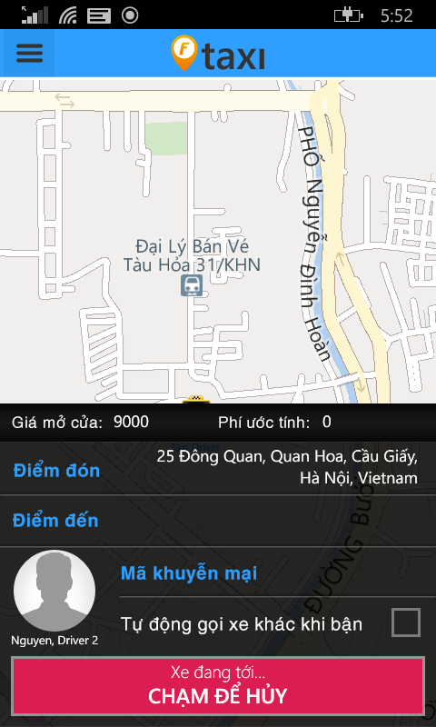

* Step 5: After Driver accept your request. You stand right your position and waiting car is coming.
* Step 6: Taxi driver pick you up and start a trip.
* Step 7: After finished a trip. Bill detail screen show up and pay your trip with cash. Tap on ”Đóng” button for back home page screen.

##### Call taxi center if no taxi around

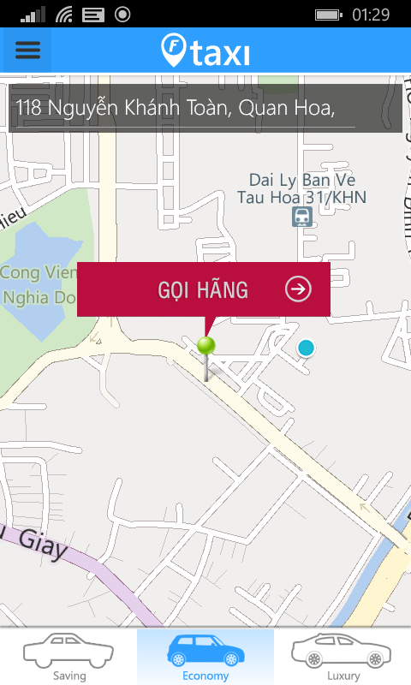

* Step 1: Tap on red “Gọi hãng” button for move to list taxi companies screen.

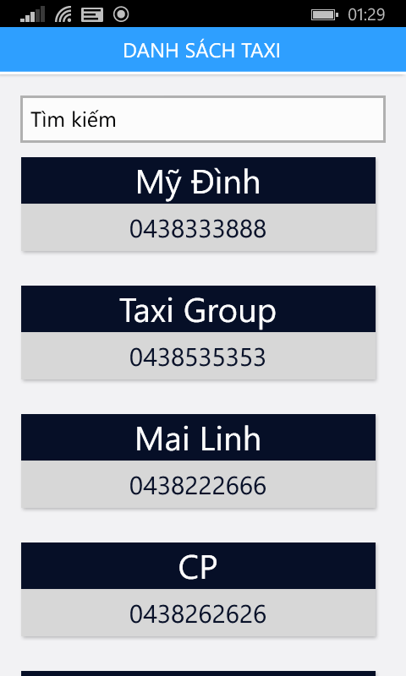

* Step 2: Tap on any taxi company for calling taxi center.
* Or enter character and tap on like :

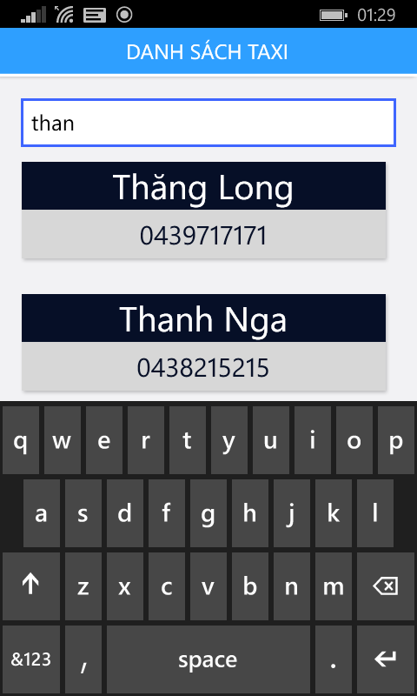

#### Left Menu

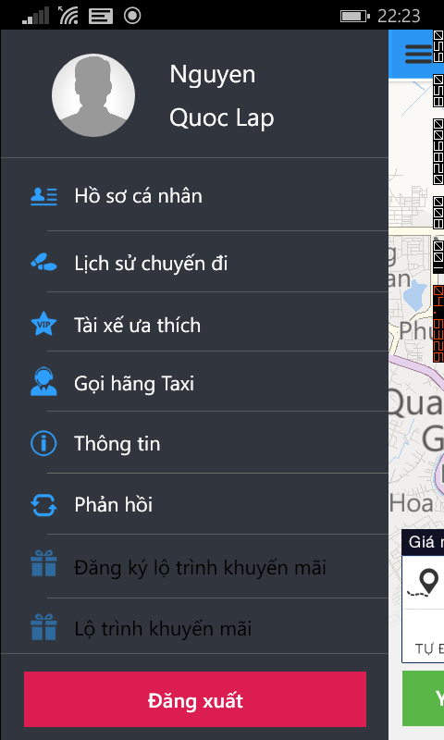

* You can tap on :
  + Avatar, Name or “Hồ sơ cá nhân” for view profile page screen.
  + “Lịch sử chuyến đi” for view history trip page screen.
  + “Tài xế ưa thích” for view favorite Driver page screen.
  + “Thông tin” for view application information.
  + “Phản hồi” for send feedback application.
  + “Đăng xuất” button for logout application.

##### Update Profile

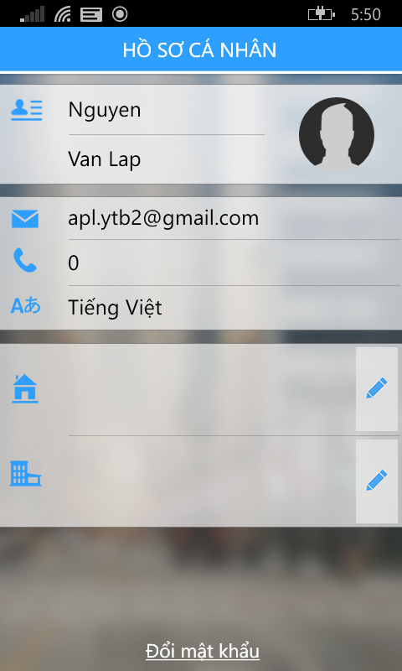

* Step 1: Tap on “Sửa” button on top right, and you enter new profile.

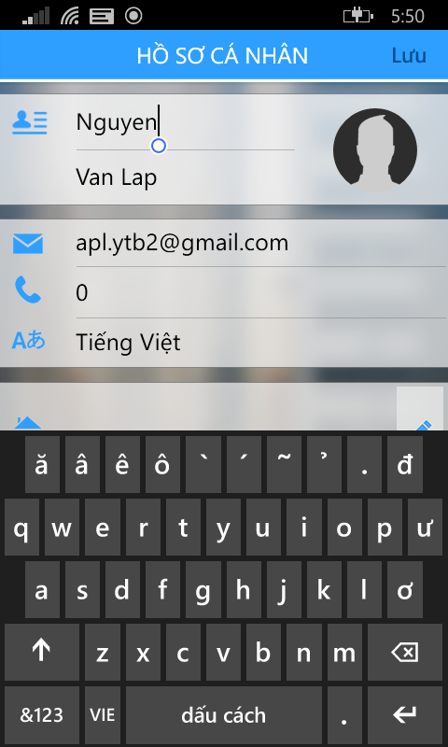

* Step 2: After enter all of change, tap on “Lưu” button for update profile.

**Update Address:**



* Step 1: Tap on pen icon , side by address for move to address page.

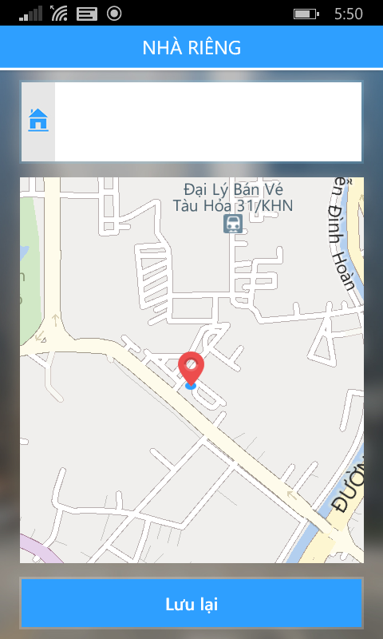

* Step 2: Enter your address and tap on “Lưu lại” button for update change address.

**Change Password:**



* Step 1: Tap on “Đổi mật khẩu” text for move change password page.

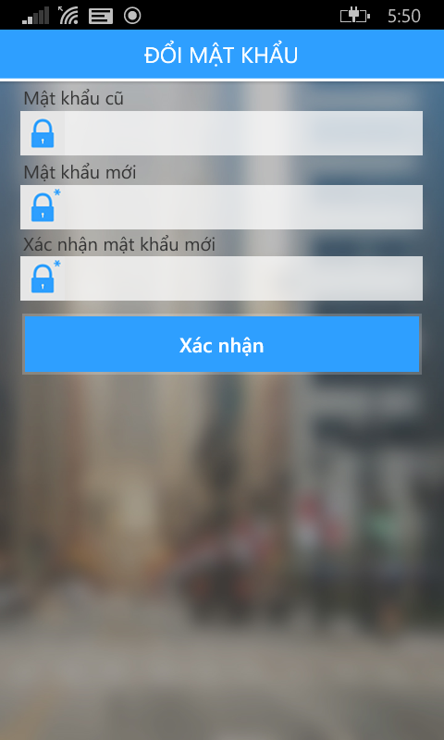

* Step 2: Fill all field and tap on “Xác nhận” button for change password.

##### View History Trip

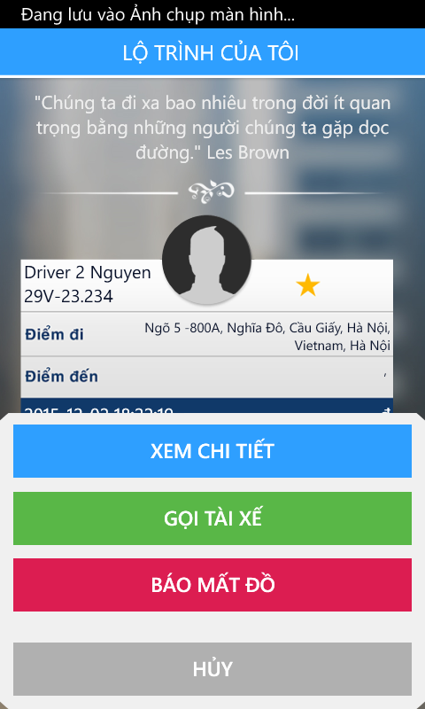

* Step 2: you can tap on :
  + Tap on “Xem chi tiết” button for view detail trip.
  + Tap on “Gọi tài xế” button for call taxi driver.
  + Tap on “Báo mất đồ” button for send notification lost asset.
  + Tap on “Hủy” button for back to view list history trip.

**Detail Trip**

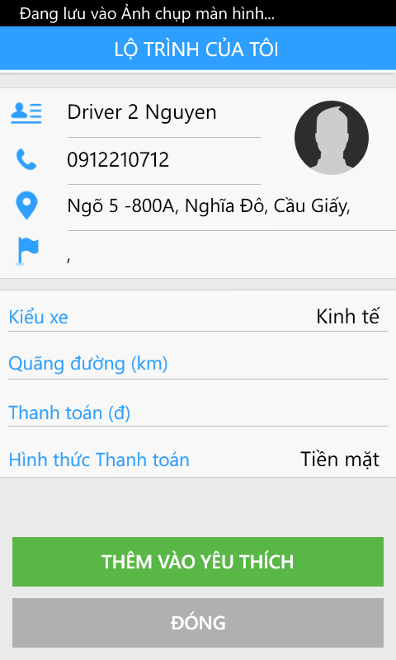

* View detail trip.
* Tap on “Thêm vào yêu thích” button for add favorite driver. Or tap on “Đóng” for close detail trip.

**Find Lost Asset**

* Fill all require field and tap on “Gửi” button.

##### View Favorite Driver

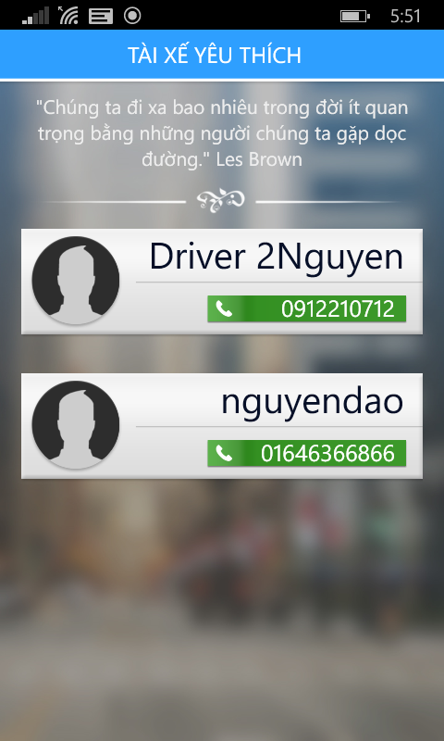

* Step 1: Tap on one of your Favorite Driver

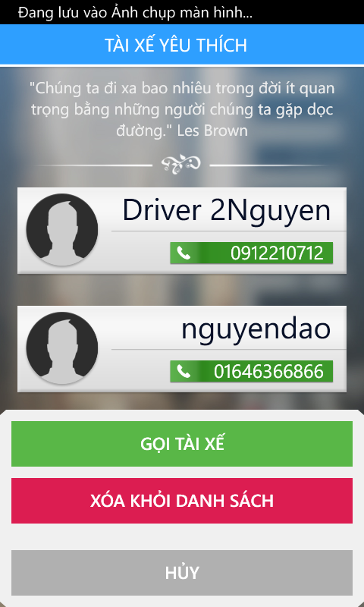

* Step 2: You can tap on :
  + “Gọi tài xế” button for calling driver instance.
  + “Xóa khỏi danh sách” button for delete favorite driver.
  + “Hủy” for back to list favorite driver.

##### Log out application



* Step 1: Tap on “Đăng xuất” button on menu bar.
* Step 2: Tap on “Có” button.

### Driver

#### Login to application

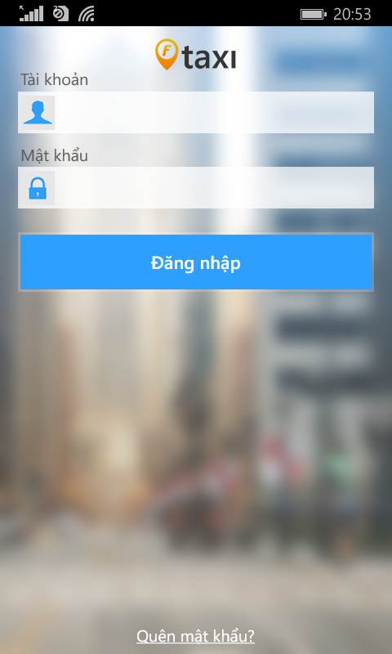

* Step 1: Fill your account on field.
* Step 2: Tap on “Đăng nhập” button.

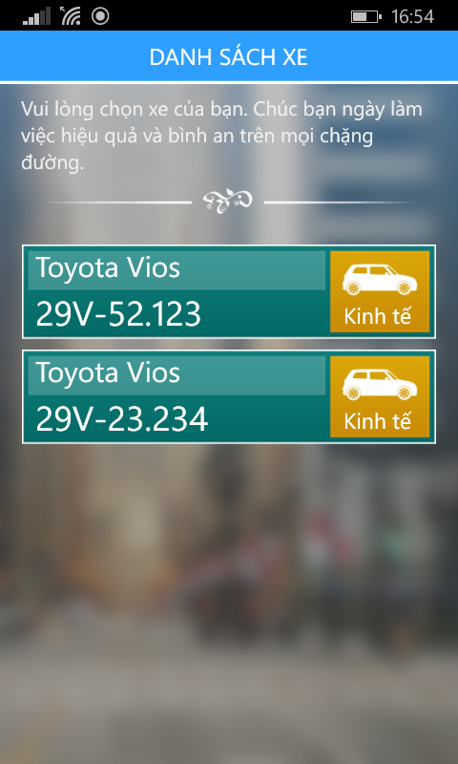

* Step 3: Choose your car.

#### Change Status

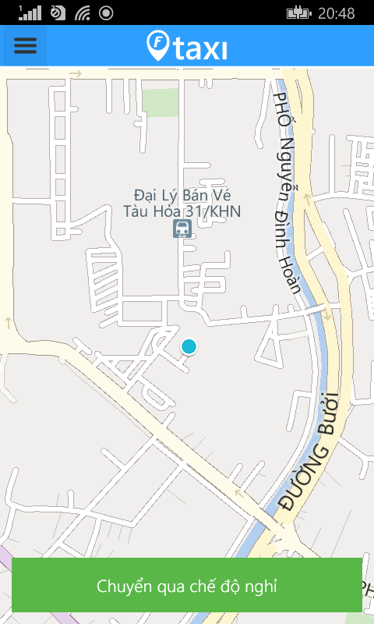

* Step 1: Tap on “Chuyển qua chế độ nghỉ” button.

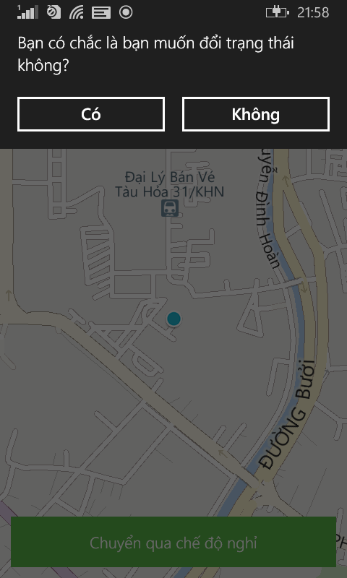

* Step 2: Tap on “Có” button.

#### Take a trip with Customer request

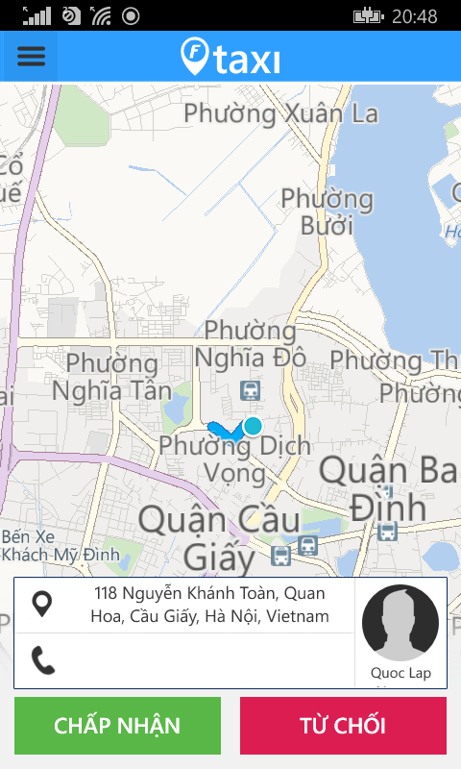

* Step 1: After received Customer request, tap on “Chấp nhận” button. And drive taxi to pick up address.

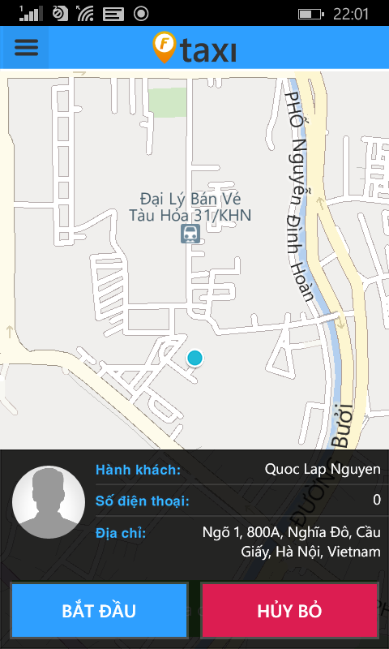

* Step 2: After pick up your customer. Tap on “Bắt đầu” button for start a trip

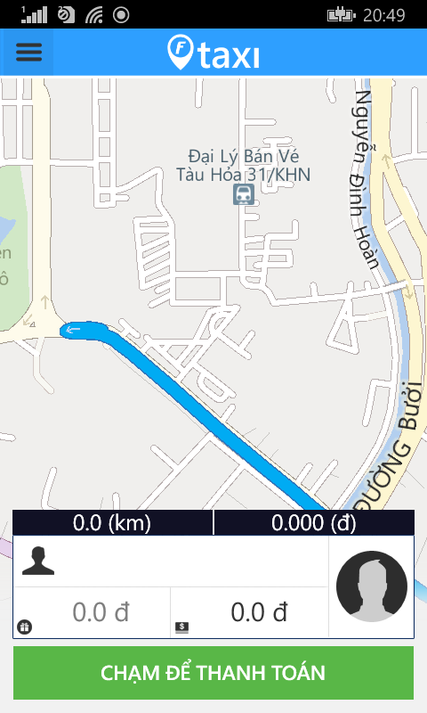

* Step 3: After finished trip. Tap on “Chạm để thanh toán” for show bill detail.

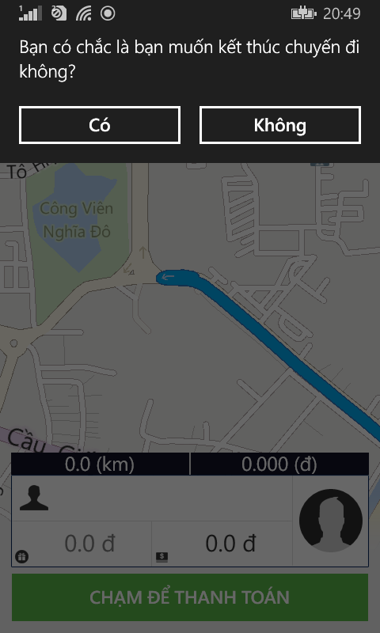

* F-Taxi will ask you want finished trip yes or not.

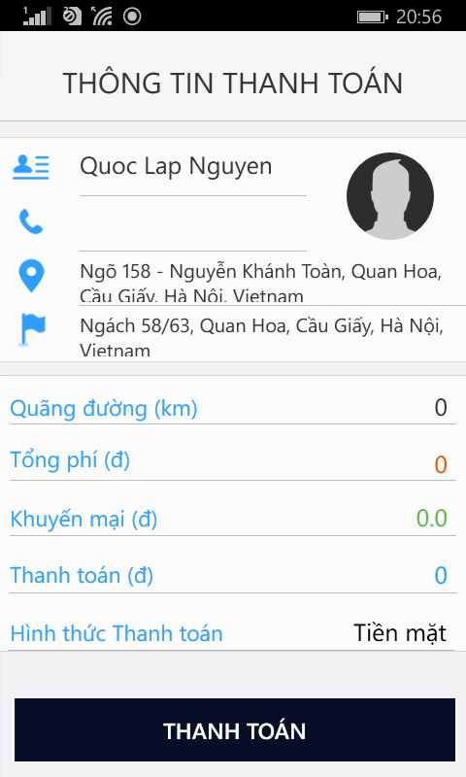

* Step 4: Receive cash from customer and tap on “Thanh toán” for end this trip.

#### Left Menu

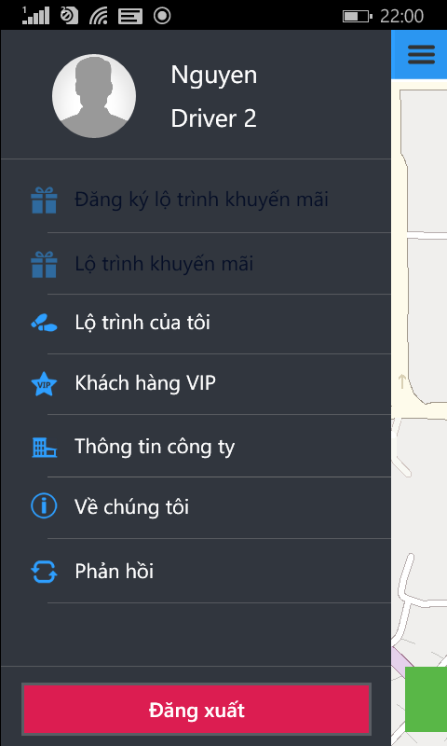

* You can tap on :
  + Avatar, Name or “Hồ sơ cá nhân” for view profile page screen.
  + “Lịch sử chuyến đi” for view history trip page screen.
  + “Thông tin công ty” for view company information.
  + “Về chúng tôi” for application information.
  + “Phản hồi” for send feedback application.
  + “Đăng xuất” button for logout application.

##### Update Profile

**Update Address:**



* Step 1: Tap on pen icon , side by address for move to address page.



* Step 2: Enter your address and tap on “Lưu lại” button for update change address.

**Change Password:**



* Step 1: Tap on “Đổi mật khẩu” text for move change password page.



* Step 2: Fill all field and tap on “Xác nhận” button for change password.

##### View Company Information

##### View History Trip

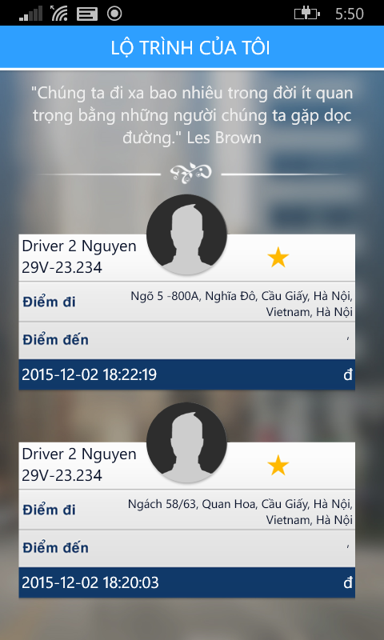

* Step 1: Tap on trip you want.



* Step 2: you can tap on :
  + Tap on “Xem chi tiết” button for view detail trip.
  + Tap on “Báo mất đồ” button for send notification lost asset.
  + Tap on “Hủy” button for back to view list history trip.

**Detail Trip**



* View detail trip.
* Tap on “Thêm vào yêu thích” button for add favorite driver. Or tap on “Đóng” for close detail trip.

**Notify Lost Asset**

Fill all require field and tap on “Gửi” button.

##### Log out application



* Step 1: Tap on “Đăng xuất” button on menu bar.
* Step 2: Tap on “Có” button.

# Reference

**Software Project Management**

1. Template Template_Project_Plan, (2010), FPT University, Hanoi, Vietnam.
2. Ian Sommerville, Software Engineering, 8th edition, (2007), USA.
3. Kathy Schwalbe, Managing Information Technology Projects, 6th edition, Cengage Learning, (2009), Canada.
4. [http://se.inf.ethz.ch/old/teaching/.../CSharpCodingStandards.pdf](http://se.inf.ethz.ch/old/teaching/ss2007/251-0290-00/project/CSharpCodingStandards.pdf).
5. <http://msdn.microsoft.com/en-us/library/ff926074.aspx>

**Software Requirement Specification**

1. Template Software_Requirements_Specification, (2010), FPT Software, Hanoi, Vietnam.

**Software Design Description**

1. Template Software_Design_Template, (2010), FPT Software, Hanoi, Vietnam.
2. Internal_Design_Template, FPT Software, Hanoi, Vietnam.
3. Kai Qian, Software Architecture and Design Illuminated, Jones & Bartlett Learning, (2010), USA.

**Software Test Documentation**

1. Templates for Test case & Defect log, FPT Software, Hanoi, Vietnam.